Name _________________________________________ AP Biology Reading Guide Fred and Theresa Holtzclaw Copyright © 2010 Pearson Education, Inc.

Chapter 15: Regulation of Gene Expression

15.1 Bacteria often respond to environmental change by regulating transcription
4) What is a gene’s promoter? What role does it serve in regulating transcription?

5) Prokaryotes use a regulatory system called an operon. Explain what an operon is:

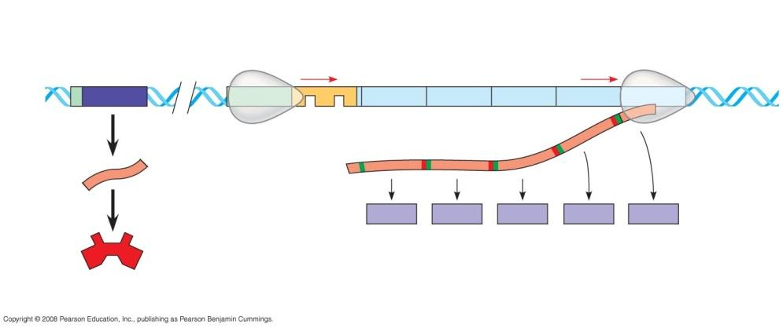

label the following diagram, and identify the function of the following components:
promoter:

operator:

repressor:

(Also label: RNA polymerase, operon, regulatory gene, start and stop codons)

6) How does a repressor protein work?

7) What are regulatory genes?

8) Distinguish between inducible and repressible operons, and describe one example of each type.

15.2 Eukaryotic gene expression is regulated at many stages
13) Even though all cells of an organism have the same genes, there is differential gene expression. What does this mean?

15) What occurs in histone acetylation? How does it affect gene expression?

16) What is DNA methylation? What role may it play in gene expression?

17) Explain what is meant by epigenetic inheritance, and give an example of epigenetic changes discussed in the text or in class.

18) Use the sketch below to explain how enhancers and activators interact with transcription factors to affect gene expression. Label the following elements: TATA box, promoter, gene, enhancer, activators, transcription factors, transcription initiation complex, RNA polymerase II, and DNA. Then place your explanation to the right of the figure.
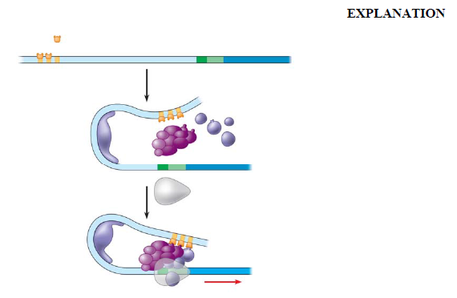

19) Operons have not been found in eukaryotic cells, and the genes coding for the enzymes of a particular metabolic pathway are often scattered over different chromosomes. What is a plausible mechanism for the coordination of gene expression?

15.3 Noncoding RNAs play multiple roles in controlling gene expression
21) Post-transcriptional control includes regulation of mRNA degradation. Explain how this affects translation.

