Name _________________________________________ AP Biology Reading Guide Fred and Theresa Holtzclaw Copyright © 2010 Pearson Education, Inc.

Chapter 14: Gene Expression: From Gene to Protein

1) What is gene expression?

14.1 Genes specify proteins via transcription and translation
2) Explain the “one gene-one polypeptide hypothesis”

6) Define each of these processes that are essential to the formation of a protein:

Transcription:

Translation:

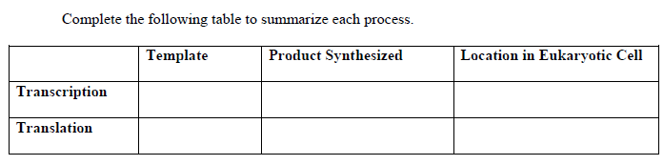
7)

8) How does the protein process differ in prokaryotes and eukaryotes?

10) Here is a short DNA template. Below it, assemble the complementary mRNA strand. Label the codons.
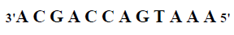

13) What is the start codon? ____________________________________________________

14) The enzyme which transcribes the DNA is ________________________________________

The strand of DNA that is transcribed is called ____________________________________

The strand of DNA that is not transcribed is called _________________________________

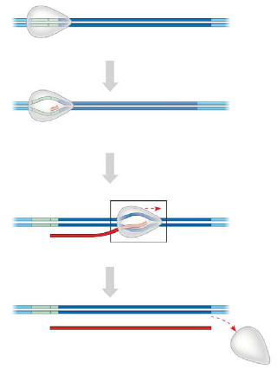
14.2 Transcription is the DNA-directed synthesis of RNA: a closer look
15) Figure 14.8 in your text will require a bit of study. Use it to label the following elements on the figure below: promoter, RNA polymerase, transcription unit, DNA template, nontemplate DNA, and RNA transcript. Then, below name the three stages of transcription and briefly describe each stage.

16) What is the TATA box? How do you think it got this name?

14.3 Eukaryotic cells modify RNA after transcription
17) RNA processing occurs only in eukaryotic cells. The primary transcript is altered at both ends, and sections in the middle are removed.

a. What happens at the 5' end?

b. What happens at the 3' end?

18) What is the advantage of the 5’ cap and poly A tail?

19) Distinguish between exons and introns.
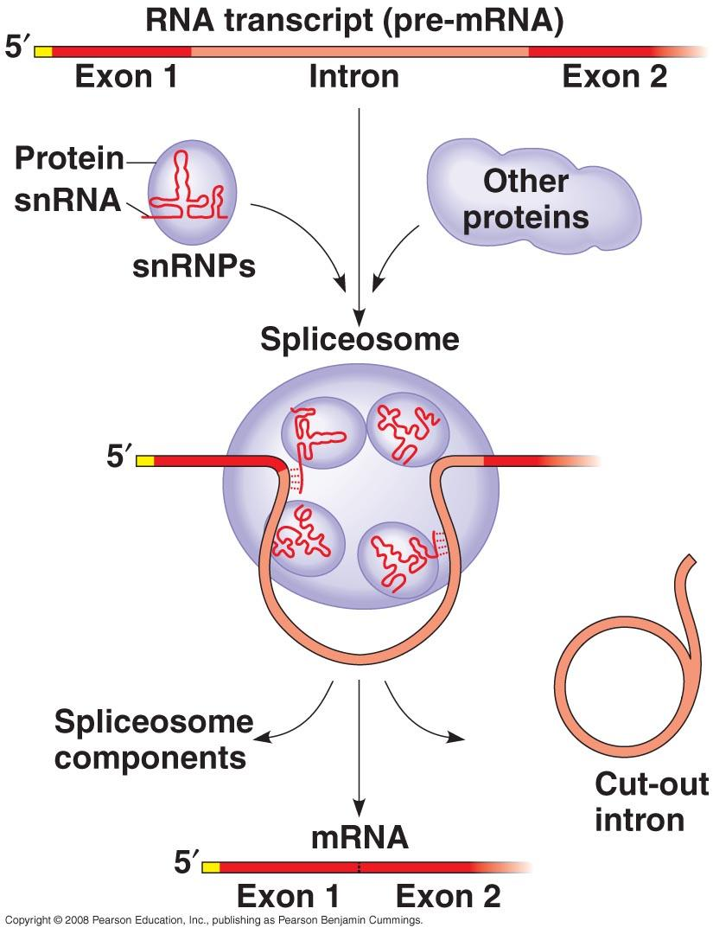

21) How do spliceosomes work? Study figure 14.13 carefully to explain how spliceosomes modify pre-mRNA.

22) What are snRNAs? What is a ribozyme? What commonly held idea was rendered obsolete by the discovery of ribozymes? When a protein and an snRNA are put together, what are they called?

14.4 Translation is the RNA-directed synthesis of a polypeptide: a closer look
23) Briefly describe the function of each type of RNA.
a. rRNA

b. mRNA

c. tRNA

24) Identify the roles of the players of the translation process.
a. Transfer RNA

b. anticodon

c. Ribosomes

25) On this figure, label the large subunit, small subunit, A, P, and E sites, mRNA binding site. To the right of the figure, explain the functions of the A, P, and E sites.

26) Summarize the events of initiation. Include these components: small ribosomal subunit, large ribosomal subunit, mRNA, initiator codon, tRNA, Met, initiation complex, P site, and GTP. The figure below may help you.
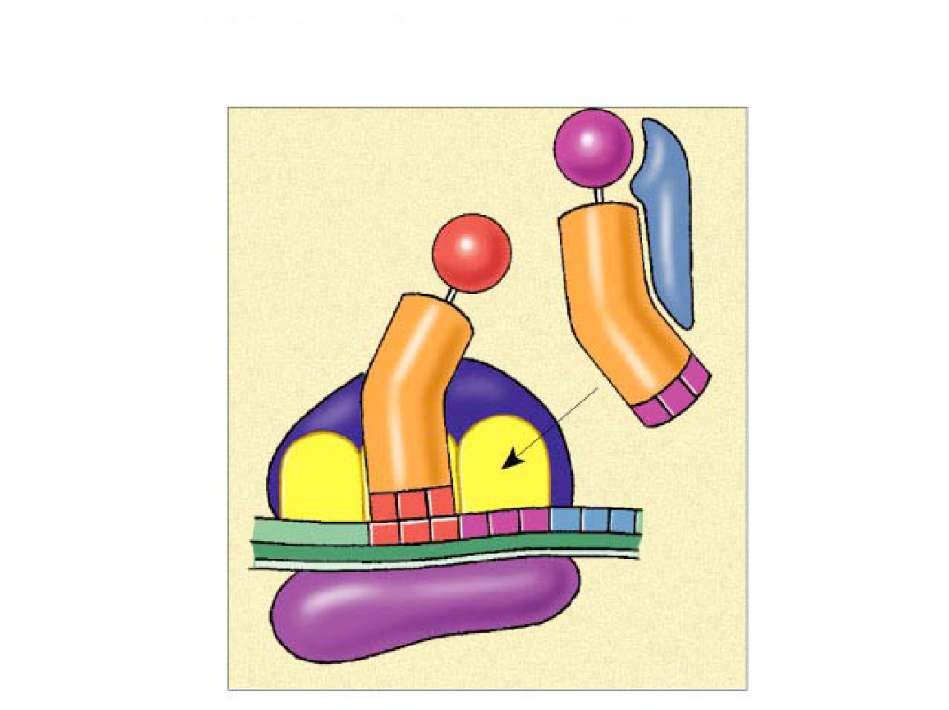

27) Now, summarize the events of elongation. Include these components: mRNA, A site, tRNA, codon, anticodon, ribozyme, P site, and E site. Again, the figure may help you.
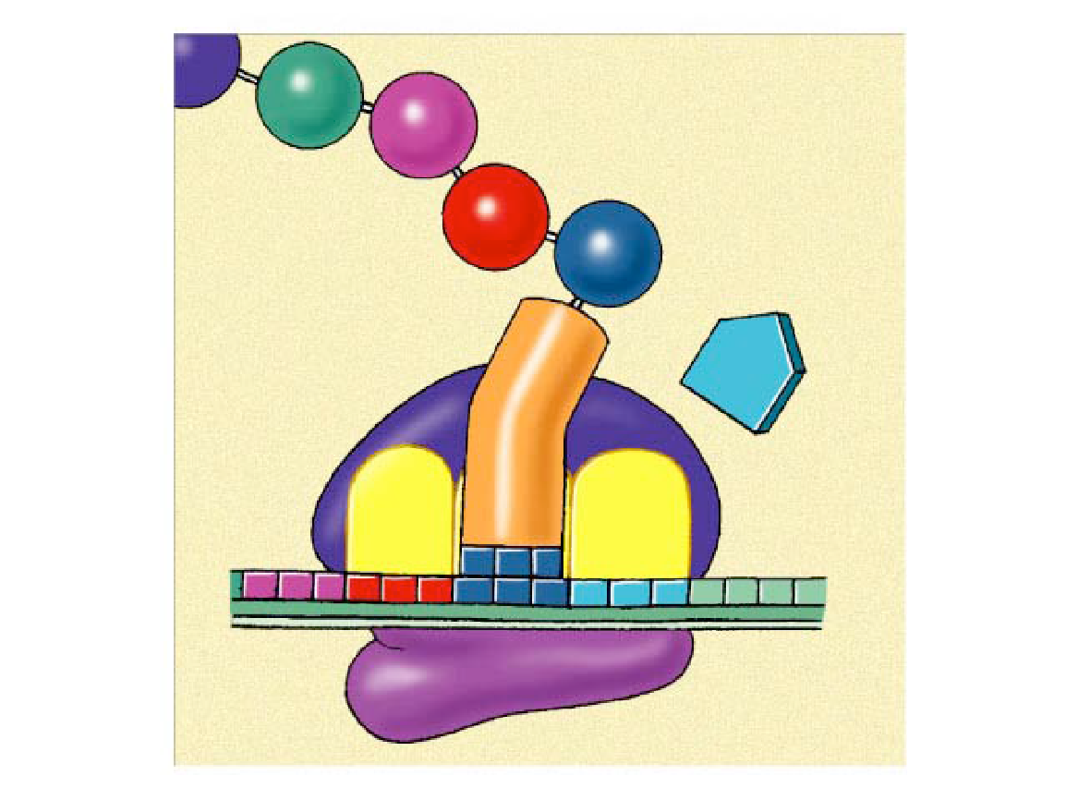

28) Explain termination and what a signal peptide is.

14.5 Mutations of one or a few nucleotides can affect protein structure and function
30) Define a mutation in terms of molecular genetics. What is a point mutation?

31) Define mutations that are:
a. frameshift

b. Missense

c. Nonsense

d. Insertion or deletion

e. Silent mutation

f. mutagens

33) Use figure 14.24 to trace the flow of chemical information from the gene to the protein product. Make sure you can explain what is going on and all the steps of protein synthesis based on this picture.
