Name _________________________________________ AP Biology Reading Guide Fred and Theresa Holtzclaw Copyright © 2010 Pearson Education, Inc.
Chapter 13-The Molecular Basis of Inheritance

13.1 DNA is the genetic material
1) What are the two chemical components of chromosomes? ___________________________________________

2) Why did researchers originally think that protein was the genetic material?

3) Use this figure (13.3) to summarize the experiment in which Griffith became aware that hereditary information could be transmitted between two organisms in an unusual manner. Make sure you state what the conclusion of his experiment was.
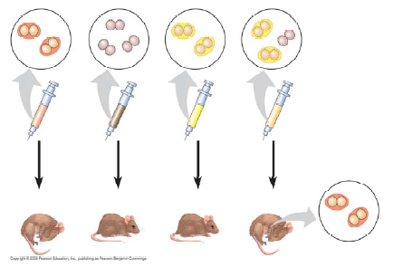

Conclusion:

4) Define transformation.

5) What did Oswald Avery determine to be the transforming factor? ___________

6) What does a bacteriophage do?

7) How did Hershey and Chase “label” viral DNA and viral protein so that they could be distinguished? Explain why they chose each radioactive tag in light of the chemical composition of DNA and protein. What conclusions did these scientists draw based on these observations?

9) Who built the first model of DNA and shared the 1962 Nobel Prize for discovery of its structure? What was the role of Rosalind Franklin in the discovery of the double helix?

10) Who discovered that adenine bonds only to thymine and cytosine to guanine?

13) Name the five nitrogenous bases, and put a checkmark in the correct column for each base. Also indicate if the base is found in DNA (D), RNA (R), or both (B).

Nitrogenous Base | D, R, or B

14) Explain what is meant by 5' and 3' ends of the nucleotide.

15) What do we mean when we say the two strands of DNA are antiparallel?

13.2 Many proteins work together in DNA replication and repair
16) What is the semiconservative model of replication?

20) Which enzyme . . .?
a..untwists and separates strands
b. holds DNA strands apart
c. synthesizes RNA primers
d. adds DNA nucleotides to the new strand
e. joins DNA fragments together
f. removes RNA primer and replaces it with DNA

18) What is the direction of synthesis of the new strand of DNA? Distinguish between the leading and the lagging strands during DNA replication.

19) What are Okazaki fragments? How are they welded together?

21) Label the following figure (13.19). Include 3' and 5' strands, RNA primer, primase, SSBP, helicase, leading strand, lagging strand, DNA polymerase, DNA ligase, parental DNA, and new DNA.
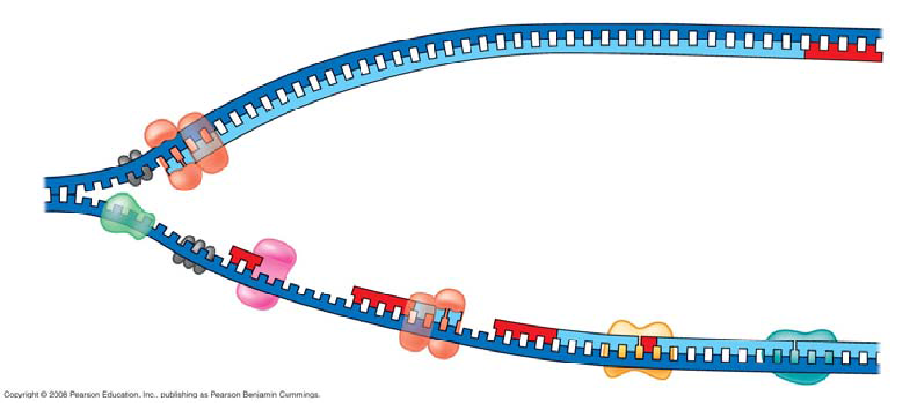

22) Put it all together! Make a list of the steps that occur in the synthesis of a new strand of DNA.

23) Explain the roles of each of the following enzymes in DNA proofreading and repair.
25) Explain telomere erosion and the role of telomerase.

26) Why can cancer cells be immortal, but most body cells have a limited life span?

13.3 A chromosome consists of a DNA molecule packed together with proteins
28) Distinguish between heterochromatin and euchromatin
13.4 Understanding DNA structure and replication makes genetic engineering possible (p. 144 in review book)
1) Define the following terms:

recombinant DNA

biotechnology

genetic engineering

Plasmid

2) The production of multiple copies of a single gene is called ____________________________.

4) Why are bacteria ideal workhorses for biotechnology? What are other organisms used in biotechnology?

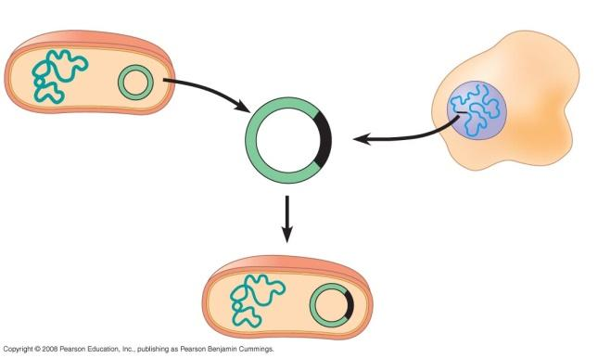
5) Using the figure, label and explain the four steps in this preview of gene cloning.

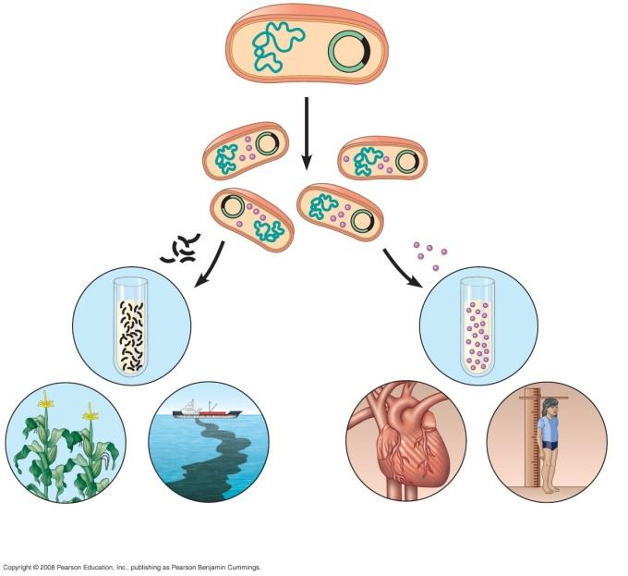

6) What are the following things and how are they used:

Restriction enzymes: What is their role in bacteria?
Why don’t restriction enzymes destroy the DNA of the bacterial cells that produce them? What is their role in genetic engineering?

Cloning vectors:

Restriction fragments:

10) Once DNA is cloned, we have the problem of finding the piece of DNA that holds our gene of interest. Explain how nucleic acid hybridization will accomplish this task.

11) Describe how a radioactively labeled nucleic acid probe can locate the gene of interest.
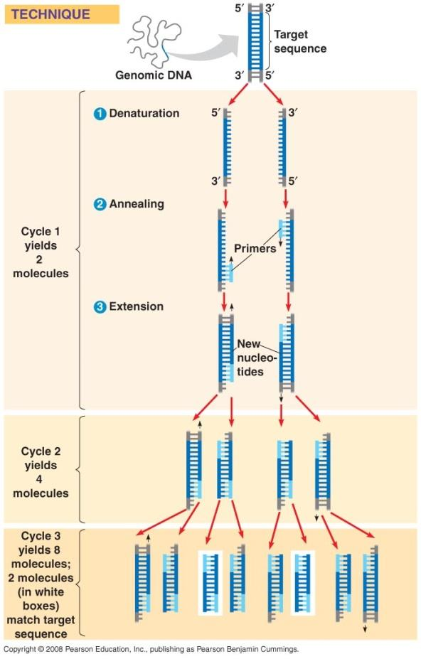

13) What is the purpose of the Polymerase Chain Reaction (demonstrated in figure 13.27)?

15) Explain the process of gel electrophoresis. In your answer be sure to include:
- Where the DNA sample is loaded and why at that end
- why shorter DNA molecules travel farther down the gel than larger molecules
- how are DNA samples separated

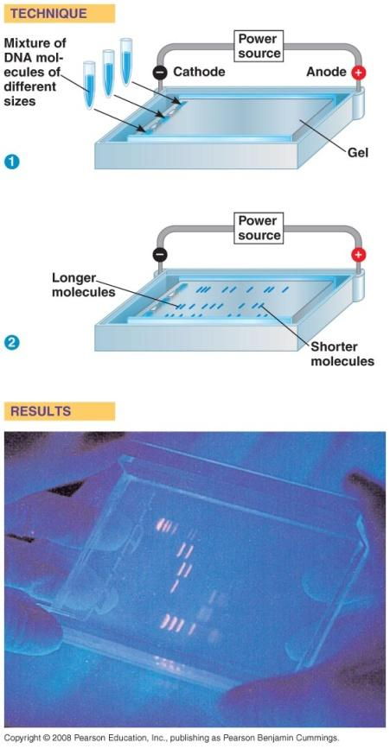

16) What is a RFLP? How are they made?

