Name _________________________________________ AP Biology Reading Guide Fred and Theresa Holtzclaw Copyright © 2010 Pearson Education, Inc.
Chapter 12-The Chromosomal Basis of Inheritance

1) What is the chromosome theory of inheritance?

2) What is the difference between the law of segregation and the law of independent assortment (see figure 12.2)?

12.1 Morgan showed that Mendelian inheritance has its physical basis in the behavior of chromosomes
3) Describe Thomas Hunt Morgan’s first mutant fruit fly. Why was this fly so significant?

5) What unusual result suggested that the eye-color trait is located on the X chromosome?

12.2 Sex-linked genes exhibit unique patterns of inheritance
7) What is meant by a trait being sex-linked?

8) Why are sex-linked recessive traits more common in males than females?

9) What is a Barr body? Why do human females show a Barr body in their cells?

12.3 Linked genes tend to be inherited together because they are located near each other on the same chromosome
12) What are linked genes? Do linked genes sort independently?

13) What is meant by parental types and recombinants in a genetic cross?

14) What is a linkage map? What is a map unit?
15) Use the figure below, which is from Figure 12.10. It shows the results of a cross between a fruit fly that is heterozygous for gray body with normal wings, and a fruit fly that has a black body with vestigial wings. Because these genes are linked, the results are not what might have been predicted. Show the phenotypes and number of each type of offspring on the chart. Indicate which offspring are the recombinants and which are the parental type. Finally, calculate the map distance between the two genes. Show all your work here.

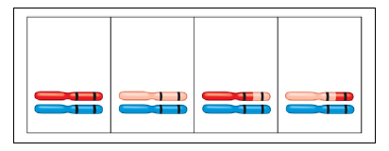
12.4 Alterations of chromosome number or structure cause some genetic disorders
16) What occurs in nondisjunction?

17) Explain each of the following terms and give a specific example of each:
aneuploidy

monosomy

trisomy

polyploidy

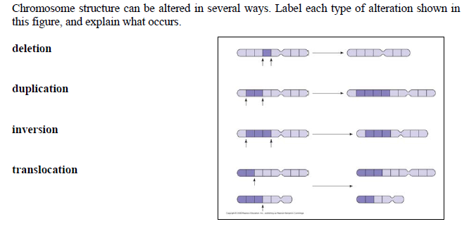
19)

The following questions can be answered from your review book p. 117.
20) A number of genes will cause a variation in phenotype, depending on whether the gene came from the father or the mother. This variation occurs because of genomic imprinting. Explain genomic imprinting.

21) Although you inherited one chromosome of each pair from your mother and your father, you have inherited a group of genes from your mother only. What genes are these and why are they called extranuclear genes?

