Name _________________________________________ AP Biology Reading Guide Fred and Theresa Holtzclaw Copyright © 2010 Pearson Education, Inc.
Chapter 11: Mendel and the Gene Idea

11.1 Mendel used the scientific approach to identify two laws of inheritance
3) Use the diagram to label the generations: P, F1, F2, pure, hybrid, and make notes of Mendel’s observations.
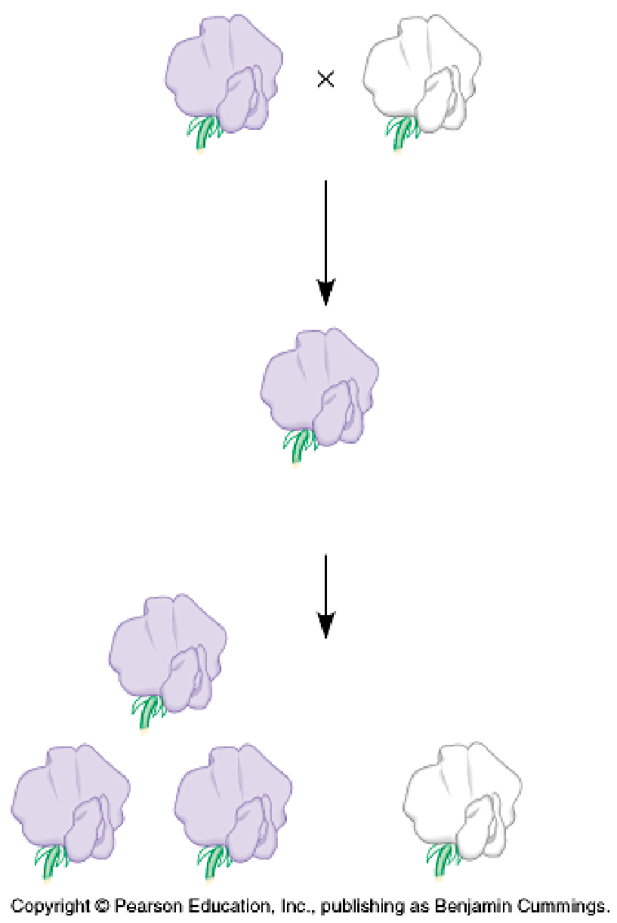
Which generation would your Mom’s grandparents be? Your Mom? You?

4) What is the difference between an allele, a gene and a locus? On the figure 11.4 below, label the allele for both purple and white flower color, a homologous pair, and the locus of the flower color gene.

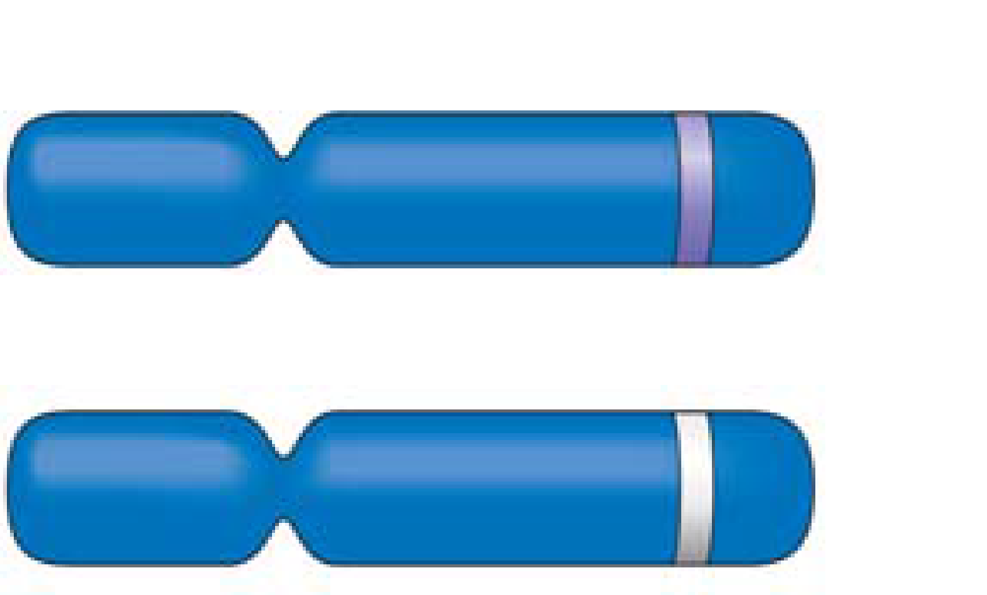
Allele:

Gene:

Locus:

Mendel’s model consists of four concepts. Describe each concept in the appropriate space below. Indicate which of the concepts can be observed during meiosis by placing an asterisk by the concept.

Mendel’s Four Concepts | Description of Concept
1st concept
2nd concept
3rd concept
4th concept
(law of segregation)

6) When does the segregation of alleles occur? _____________________________________

7) Briefly define the following terms:
a. homozygous _____________________________________________________________________________________
b. heterozygous ____________________________________________________________________________________
c. phenotype _______________________________________________________________________________________
d. genotype ________________________________________________________________________________________

8) In humans the allele for albinism is recessive to the allele for normal skin pigmentation. If two heterozygotes have children, what is the chance that a child will have normal skin pigment? What is the chance that a child will be albino?
Show all work and all percentages!!! (You may use “A” for normal pigmentation and “a” for albino.)

Genotype frequency phenotype frequency

9) What is the purpose of a testcross?

11) Explain the difference between a monohybrid cross and a dihybrid cross.

12) Complete the cross YyRr × YyRr by placing the gametes in a Punnett square. Then provide the phenotypic ratio of the offspring. (Where Y is the allele for yellow peas, y is for green, R is for round peas and r is for wrinkled.)

13) Explain Mendel’s law of independent assortment.

11.2 Probability laws govern Mendelian inheritance
14) Look over the probability rules/concepts (independent event, multiplication rule, and addition rule). Make sure you understand them. What is the probability that a couple will have a girl, a boy, a girl, and a boy in this specific order? Show All Work!!!!

11.3 Inheritance patterns are often more complex than predicted by simple Mendelian genetics
15) Explain how incomplete dominance is different from complete dominance, and codominance and give an example of each.

16) How is blood type an example of multiple alleles?

17) Review blood types (see figure 11.11). If a man with type AB blood marries a woman with type O blood, what blood types would you expect in their children? Include genotypic and phenotypic ratios Show all work!!!

Describe pleiotropy and epistasis.

18) Why is height a good example of polygenic inheritance?

11.4 Many human traits follow Mendelian patterns of inheritance
21) Pedigree analysis is often used to determine the mode of inheritance (dominant or recessive, for example). Be sure to read the “Tips for pedigree analysis” in Figure 14.15; then complete the unlabeled pedigree by indicating the genotypes for all involved. What is the mode of inheritance for this pedigree? (First decide if it is recessive or dominant, then autosomal or sex-linked). Show work on the pedigree chart.
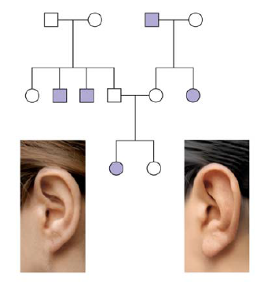

22) Explain why you know the genotype of one female in the third generation, but are unsure of the other.

23) Briefly describe each of the following recessively inherited genetic disorders:
a. Cystic fibrosis

b. Tay-Sachs

c. Sickle cell anemia

e. Explain how Huntington’s disease can be passed on even though it is a lethal dominant allele.

24) Give two examples of fetal testing and explain how they are done.

