Name _________________________________________ AP Biology Reading Guide
Fred and Theresa Holtzclaw Copyright © 2010 Pearson Education, Inc.

Chapter 10: Meiosis and Sexual Life Cycles

10.2 Fertilization and meiosis alternate in sexual life cycles
1) What is the difference between sex chromosomes and autosomes? How many of each is found in human cells?

2) What is a karyotype and what is it used for?

3) Explain what is meant by homologous chromosomes (homologs).

4) The muscle cells of a dog have 78 chromosomes. Fill in the correct chromosome number in a:

Bone cell ________ sperm ________ haploid cell _______ somatic cell ________ zygote ________

5) In the diagram label the following:
- sister chromatids
- homologous chromosomes
- centromere
- replicated chromosome
- maternal chromosomes

6) In the above cell:

How many chromosomes does it have? __________

How many homologous pairs? __________

How many chromatids? _________

Is this cell haploid or diploid? __________

7) Where are the gametes of humans produced and name the specific meiotic process they are produced by?

Males produced in: ______________________________ process name: ___________________________

Females produced in: ____________________________ process name: ___________________________

8) What is the purpose of meiosis?

10.3 Meiosis reduces the number of chromosome sets from diploid to haploid
10) How many divisions does Meiosis go through? __________

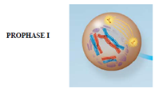
Lets study the events of meiosis I.
11) Explain each of the following events that occurs during Prophase 1
synapsis

crossing over (and the resulting recombinant DNA)

chiasmata

12) In Metaphase 1. How is the arrangement of chromosomes different from metaphase of mitosis?
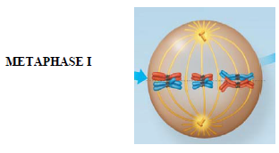

13) Now look at Anaphase 1 and Telophase 1.
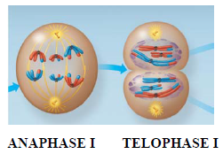
What separates and goes to the poles in Anaphase I? ______________________

What is the process after telophase called? _____________________________

How many chromosomes are in each cell at the end of the first division? __________

*Are the resulting daughter cells haploid or diploid? ____________________________*

14) During Meiosis I the homologous chromosomes separate. What separates during meiosis II?

15) Recap:
During which division is the chromosomes number reduced? _____________________

How many times do the chromosomes duplicate? ___________________

How many “daughter cells” are formed? _________________________

What is the chromosome number? 2n or n? ______________________________________

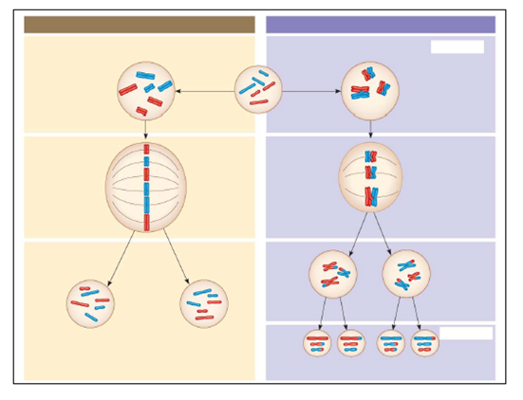
16) In the figure below compare mitosis and meiosis. Add the following labels to the picture:
Parent cell, Mitosis, Meiosis, Synapsis, Homologs, sister chromatids, daughter cells, Meiosis I, Meiosis II, Crossing over, disjunction, 2n, and n

List the 3 events that occur during meiosis I that do not occur in mitosis.

17) Students often get confused about the differences between mitosis and meiosis. To help, work through the chart.
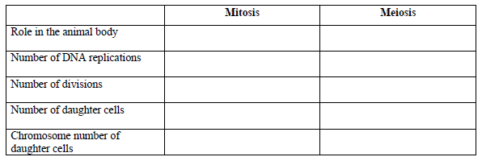

10.4 Genetic variation produced in sexual life cycles contributes to evolution
18) An important idea for you to understand is that new alleles arise by changes in the DNA or mutation, but genetic diversity occurs when the deck that is dealt is simply reshuffled. So, there are three ways that sexually reproducing organisms “shuffle the deck.” They are listed below. Explain what occurs in each, and how this increases diversity/evolution.
independent assortment of chromosomes

crossing over

random fertilization

