Name ___________________________
AP Biology

Chapter 56 - Conservation Biology and Global Change

Guided Reading Assignment Campbell’s 10th Edition

Essential Knowledge
2.D.2 Homeostatic mechanism reflect both common ancestry and divergence due to adaptation in different environments
2.D.3 Biological systems are affected by disruptions to their dynamic homeostasis
4.B.4 Distribution of local and global ecosystems change over time
4.C.4 The diversity of species within an ecosystem may influence the stability of the ecosystem

LO 4.21 The student is able to predict consequences of human actions on both local and global ecosystems.

- List and describe three levels of biodiversity

- Describe three benefits of species and genetic diversity

- Give examples of ecosystem services

- 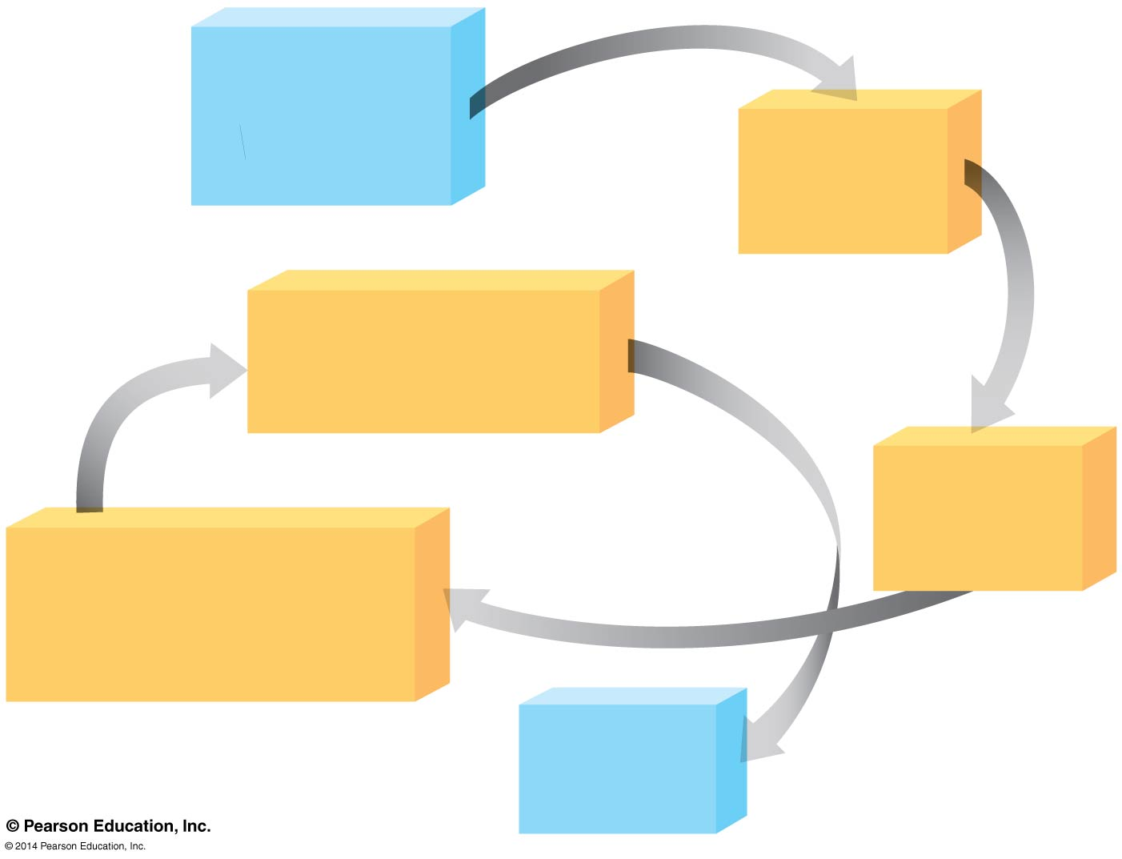List and describe three threats to biodiversity

- Label the diagram of processes driving an extinction vortex

- How do movement corridors benefit fragmented habitats

- How do biodiversity hotspots help focus restoration efforts

- List and describe three human actions causing the Earth to change

- What factors make development sustainable?

