**Name ___________________________**

**AP Biology**

**Chapter 55 - Ecosystems and Restoration Ecology**

**Guided Reading Assignment Campbell’s 10th Edition**

**Essential Knowledge**

2.A.1 All living systems require constant input of free energy

2.D.1 All biological systems from cells and organisms to populations, communities, and ecosystems are affected by complex biotic and abiotic interactions involving exchange of matter and free energy

4.A.6 Interactions among living systems and with their environment result in the movement of matter and energy

LO 4.20 The student is able to explain how the distribution of ecosystems changes over time by identifying large-scale events that have resulted in these changes in the past.

1. What is an ecosystem and why would we study energy flow in relation to the ecosystem?
2. Label the diagram below.

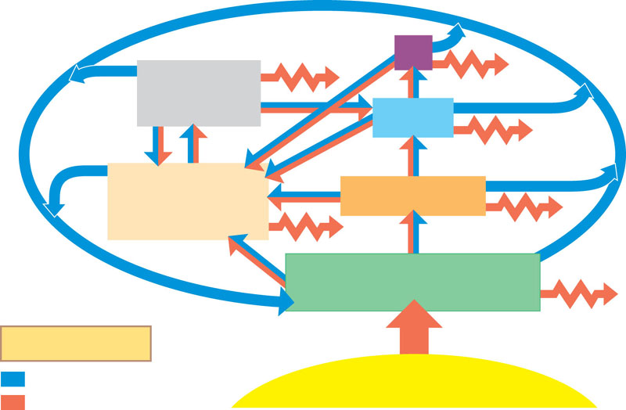

1. Why are detrivores essential to an ecosystem?
2. Define the following terms:
   1. Gross primary production
   2. Net primary production
3. How do light limitations and nutrient limitations impact primary production?
4. What is eutrophication and is it considered a “positive” for the lake environment?
5. What impacts evapotranspiration?
6. What is secondary production?
7. Why is the energy transfer between trophic levels limited?
8. What is the difference between production efficiency and tropic efficiency?

1. Briefly detail the biological significance of the water cycle. (be sure to mention transpiration from plants)
2. Briefly detail the biological significance of the carbon cycle. (be sure to mention photosynthesis and respiration)
3. Briefly detail the biological significance of the nitrogen cycle. (be sure to mention nitrogen fixing bacteria)
4. What is the difference between nitrification, denitrification, ammonification and nitrogen fixation?
5. Describe the process of bioremediation