**Name __________________________**

**AP Biology**

**Chapter 53 - Population Ecology**

**Guided Reading Assignment Campbell’s 10th Edition**

**Essential Knowledge**  
2.D.1 All biological systems from cells and organisms to populations, communities, and ecosystems are affected by complex biotic and abiotic interactions involving exchange of matter and free energy

4.A.5 Communities are composed of populations of organisms that interact in complex ways

2.D.1 All biological systems from cells and organisms to populations, communities, and ecosystems are affected by complex biotic and abiotic interactions involving exchange of matter and free energy

2.A.1 All living systems require constant input of free energy

LO 1.8 The student is able to make predictions about the effects of genetic drift, migration and artificial selection on the genetic makeup of a population.

LO 2.3 The student is able to predict how changes in free energy availability affect organisms, populations, and/or ecosystems.

LO 4.19 The student is able to use data analysis to refine observations and measurements regarding the effect of population interactions on patterns of species distribution and abundance.

1. Define the following terms:
   1. Population
   2. Density
   3. Dispersion
   4. Mark-recapture method
   5. Immigration
   6. Emigration

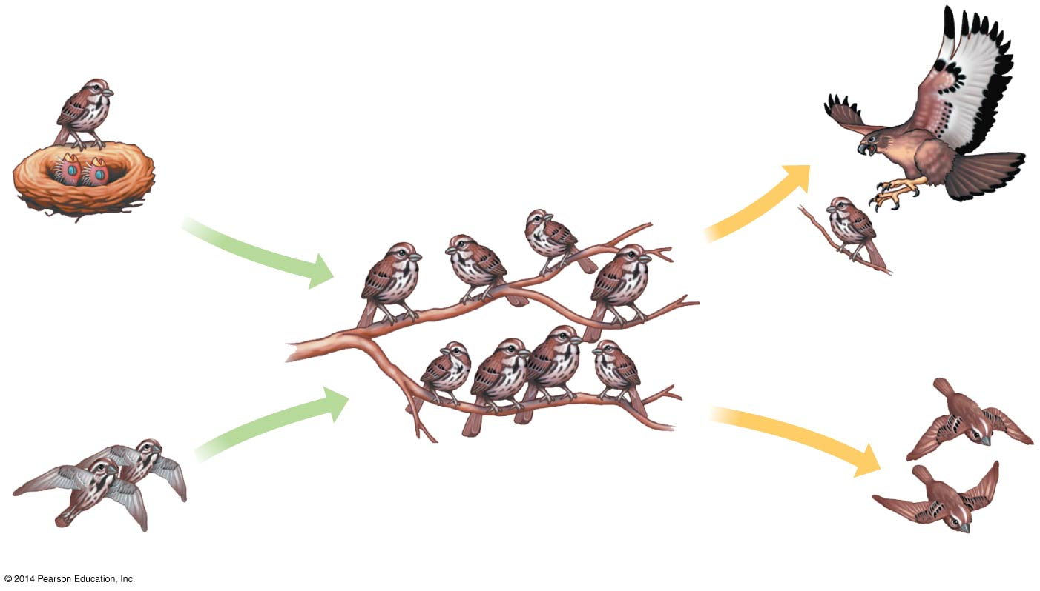

* 1. Territoriality

1. Using the diagram, label two factors that increase population and two factors that decrease population
2. Label the three patterns of dispersion. What could cause each of these patterns?

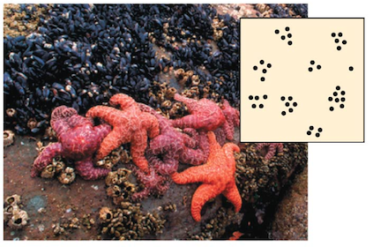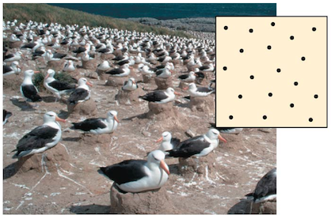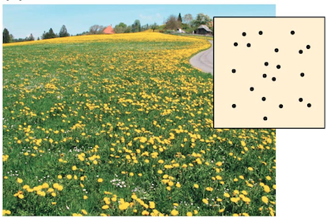

1. Define the following terms:
   1. Demography
   2. Life tables
   3. Survivorship curves
   4. Reproductive table
   5. Life history

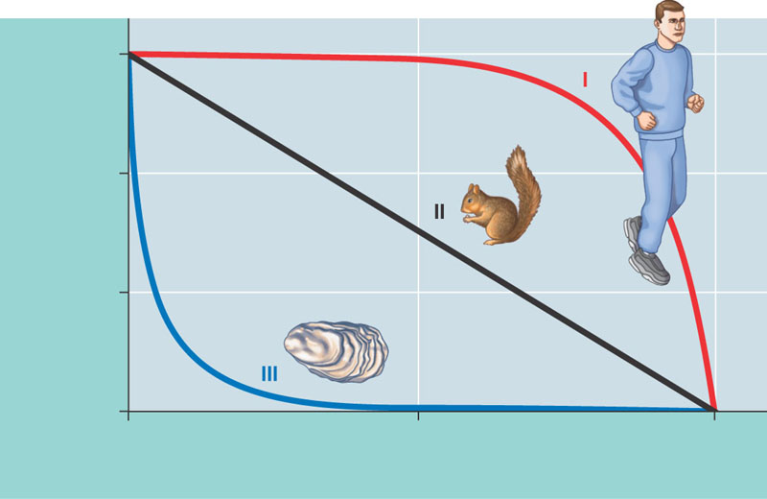

1. Use the diagram– label the three different survivorship curves – give an example of an animal that fits each curve and an explanation of why they fit the curve.

1. What information is used to construct a reproductive table

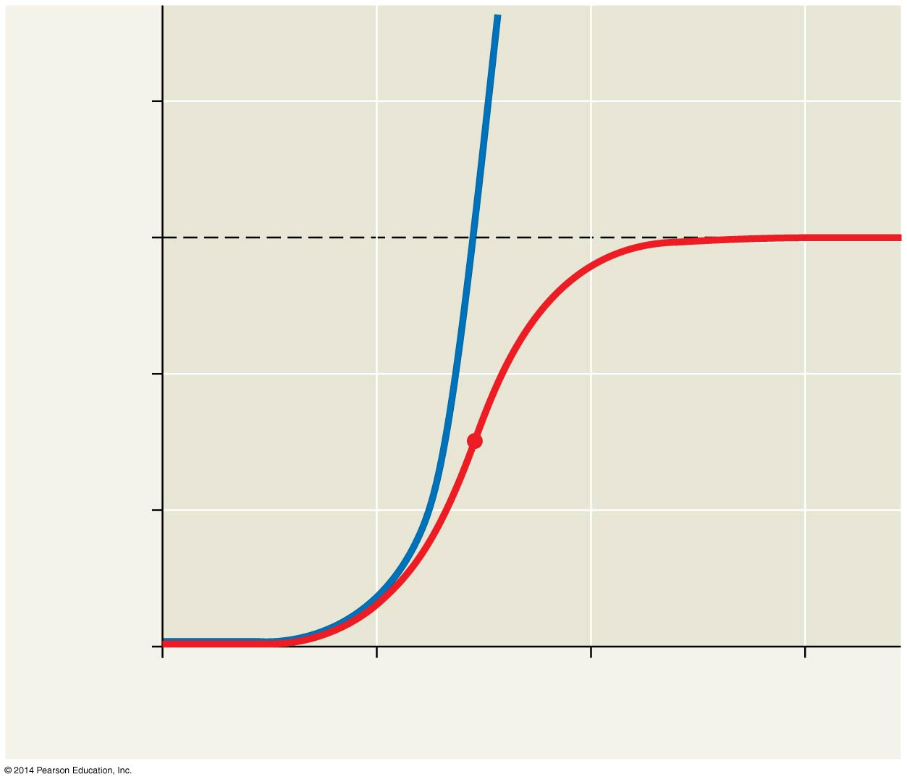

1. Label exponential population growth on the diagram.
2. When is this type of growth seen?
3. Label logistic population growth on the diagram.

1. When is this type of growth seen?
2. You will practice using the equations for logistic and exponential growth curves during this unit. Take a look at the equations and explain how they differ

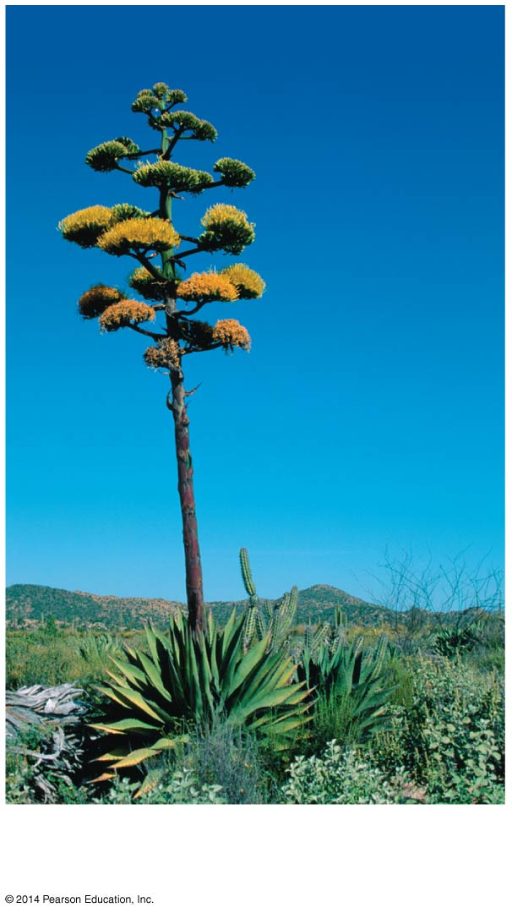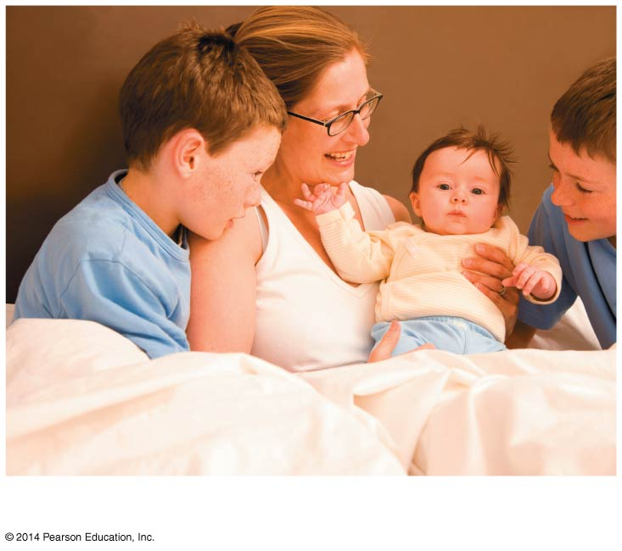

1. Define and label two types of parity and give advantages and disadvantages of each

1. Compare and contrast r and k selection – this is a key concept – do some additional research and try to come up with at lease six points of comparison.
2. What is the difference between density-dependent and density-independent factors as a general term?
3. What generalizations can be made by the graphs below?

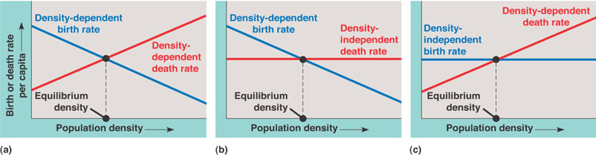

1. Describe six density-dependent factors in population regulation.

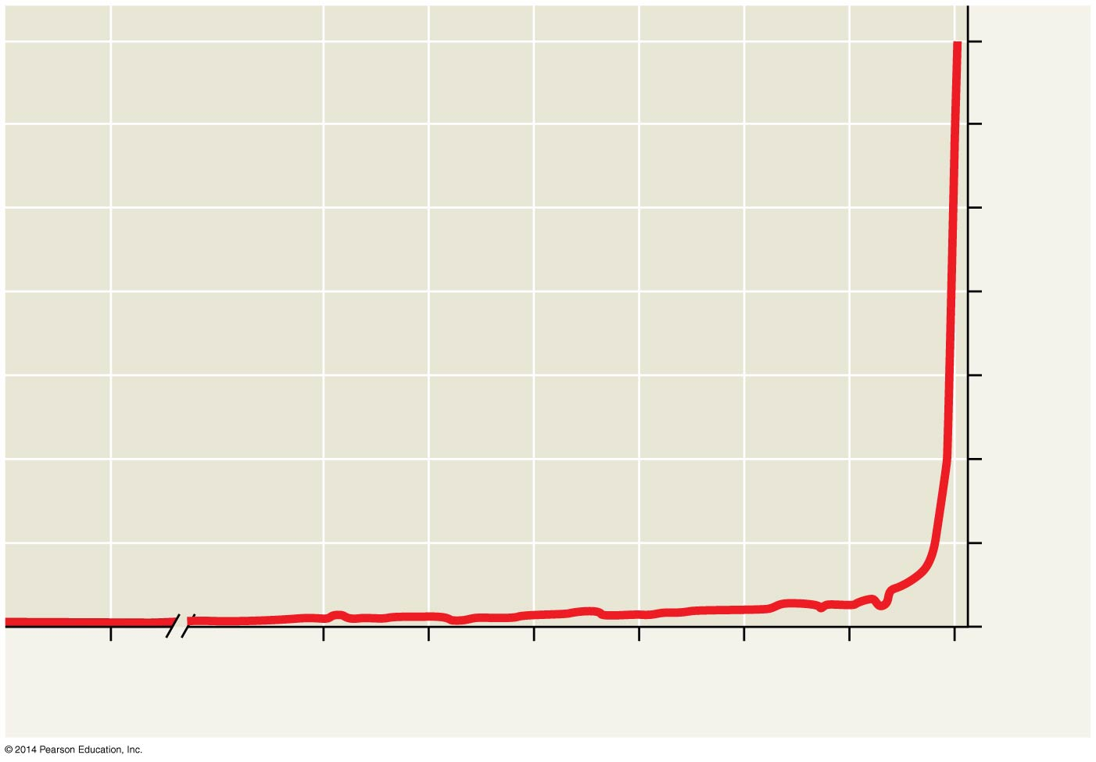

1. What is population dynamics?

1. Describe human population growth using the diagram.
2. What kinds of information do age structure pyramids provide and what inferences can be made from these?
3. How can an ecological footprint be useful?