Name __________________________
AP Biology

Chapter 52 - An Introduction to Ecology and the Biosphere

Guided Reading Assignment Campbell’s 10th Edition

Essential Knowledge
2.D.1 All biological systems from cells and organisms to populations, communities, and ecosystems are affected by complex biotic and abiotic interactions involving exchange of matter and free energy

LO 2.22 The student is able to refine scientific models and questions about the effect of complex biotic and abiotic interactions on all biological systems, from cells and organisms to populations, communities and ecosystems.
LO 2.23 The student is able to design a plan for collecting data
to show that all biological systems (cells, organisms, populations, communities and ecosystems) are affected by complex biotic and abiotic interactions.
LO 2.24 The student is able to analyze data to identify possible patterns and relationships between a biotic or abiotic factor and a biological system (cells, organisms, populations, communities or ecosystems).
LO 4.14 The student is able to apply mathematical routines to quantities that describe interactions among living systems and their environment, which result in the movement of matter and energy.
LO 4.15 The student is able to use visual representations to analyze situations or solve problems qualitatively to illustrate how interactions among living systems and with their environment result in the movement of matter and energy.
LO 4.16 The student is able to predict the effects of a change of matter or energy availability on communities.

- What causes the seasons

- How can mountains lead to microclimates

- Define and give examples of the following terms:
  - Abiotic
  - Biotic

Specific terrestrial and marine biomes are not studied in this course. You are expected to know and understand them from your previous science courses. Please review them if you do not.
- Define and give examples of a biome

- What variables work together to determine which terrestrial biomes will occur in specific areas at specific times?
- 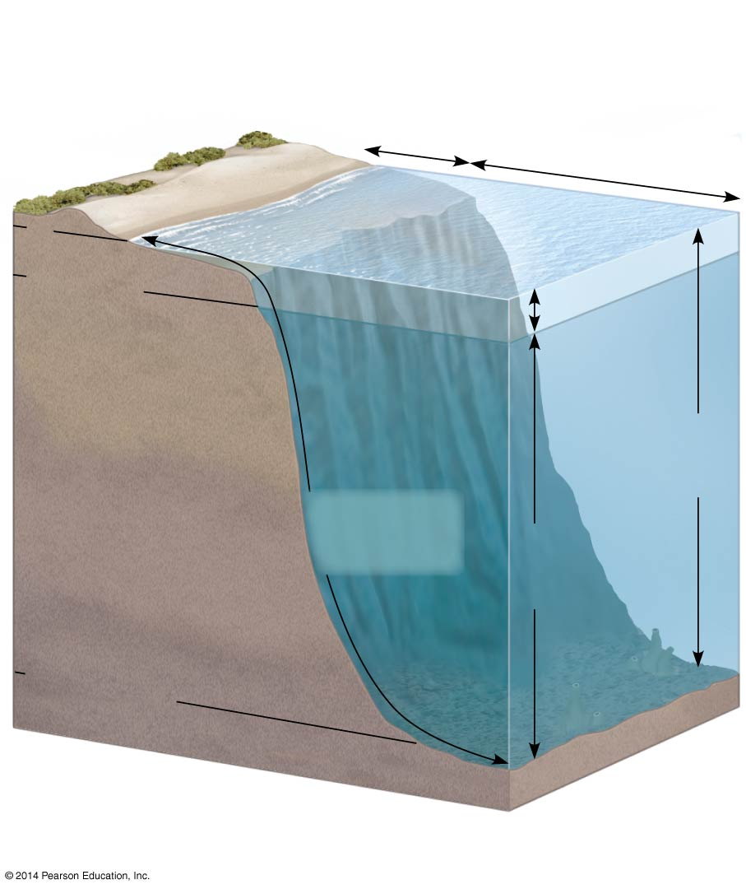What three variables are used to classify aquatic environments?

- Label the zonation of the marine environment shown in the diagram

- Explain the factors that affect dispersal of organisms.

- Give two examples of the impact of abiotic factors on the distribution of organism:
  - Temperature
  - Water
  - Sunlight
  - Wind
  - Rocks and soil
- How does seasonal turnover in lakes affect the oxygen level available to the aquatic organisms?

