Name __________________________
AP Biology

Chapter 51 - Animal Behavior

Guided Reading Assignment Campbell’s 10th Edition

Essential Knowledge
3.E.1 Individuals can act on information and communicate it to others
2.E.3 Timing and coordination of behavior are regulated by various mechanisms and are important in natural selection
2.A.1 All living systems require constant input of free energy
1.A.1 Natural selection is a major mechanism of evolution
1.A.2 Natural selection acts on phenotypic variations in populations
1.A.3 Evolutionary change is also driven by random processes
1.A.4 Biological evolution is supported by scientific evidence from many disciplines, including mathematics
1.A.2 Natural selection acts on phenotypic variations in populations

LO 2.15 The student can justify a claim made about the effect(s) on a biological system at the molecular, physiological or organismal level when given a scenario in which one or more components within a negative regulatory system is altered.
LO 2.18 The student can make predictions about how organisms use negative feedback mechanisms to maintain their internal environments.
LO 2.19 The student is able to make predictions about how positive feedback mechanisms amplify activities and processes in organisms based on scientific theories and models.
LO 2.21 The student is able to justify the selection of the kind of data needed to answer scientific questions about the relevant mechanism that organisms use to respond to changes in their external environment.
LO 2.42 The student is able to pose a scientific question concerning the behavioral or physiological response of an organism to a change in its environment.
LO 2.38 The student is able to analyze data to support the claim that responses to information and communication of information affect natural selection.
LO 2.39 The student is able to justify scientific claims, using evidence, to describe how timing and coordination of behavioral events in organisms are regulated by several mechanisms.
LO 2.40 The student is able to connect concepts in and across domain(s) to predict how environmental factors affect responses to information and change behavior.
LO 3.40 The student is able to analyze data that indicate how organisms exchange information in response to internal changes and external cues, and which can change behavior.
LO 3.41 The student is able to create a representation that describes how organisms exchange information in response to internal changes and external cues, and which can result in changes in behavior.
LO 3.42 The student is able to describe how organisms exchange information in response to internal changes or environmental cues.
LO 4.8 The student is able to evaluate scientific questions concerning organisms that exhibit complex properties due to the interaction of their constituent parts.

- Describe behavior in your own words

- What is the focus of:
  - Proximate questions of behavior?
  - Ultimate questions of behavior?
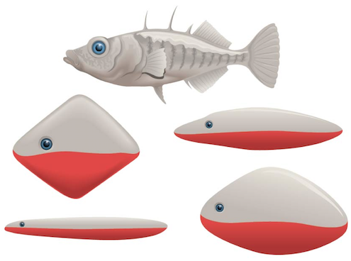
- Using the diagram provided, describe a fixed action pattern.

- What is the sign stimulus of this response?

- What is the evolutionary advantage of fixed action patterns?
- Describe how birds might use magnetoreceptors to guide migration

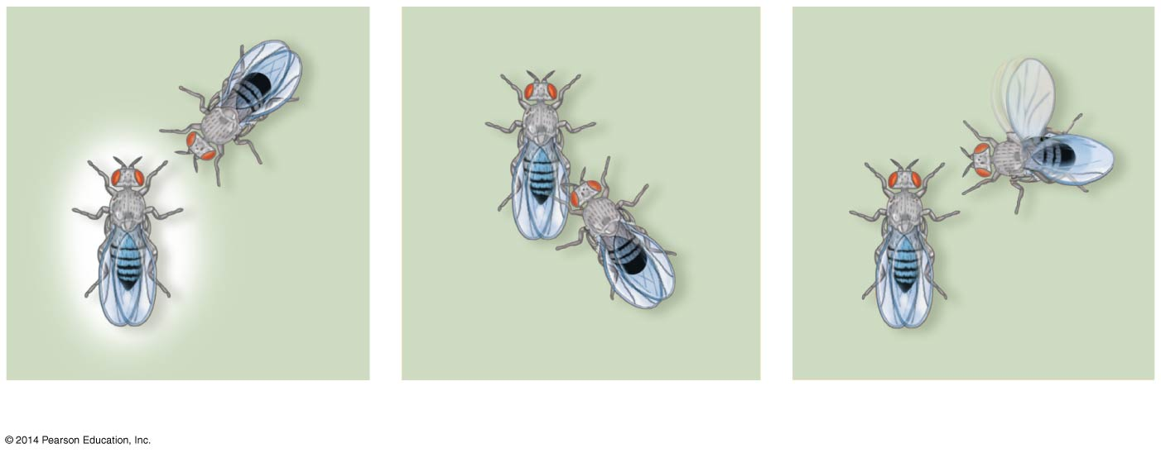
- Label the three phases of fruit fly courtship

- Explain how honeybees communicate the location of nectar.

- What is a pheromone, explain how it functions differently than a hormone.

- Define and give three examples of a innate behaviors

- How does learning affect behavior?

- Explain the experiment that first demonstrated imprinting.

- What is the evolutionary advantage of imprinting?

- Describe associative learning

- Give examples of operant and classical conditioning
  - Operant

  - Classical

- Label each diagram showing a specific mating system

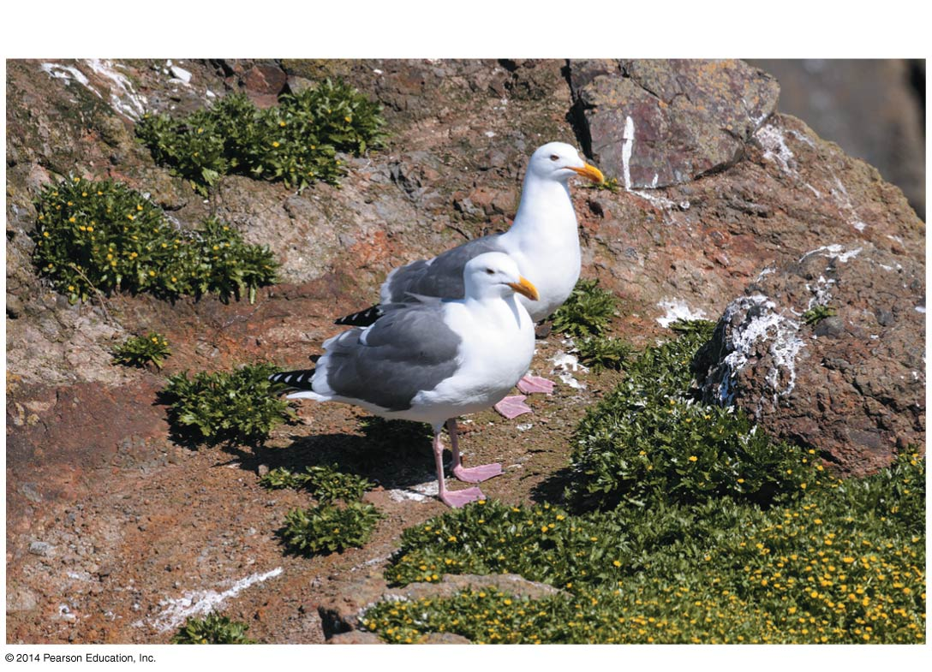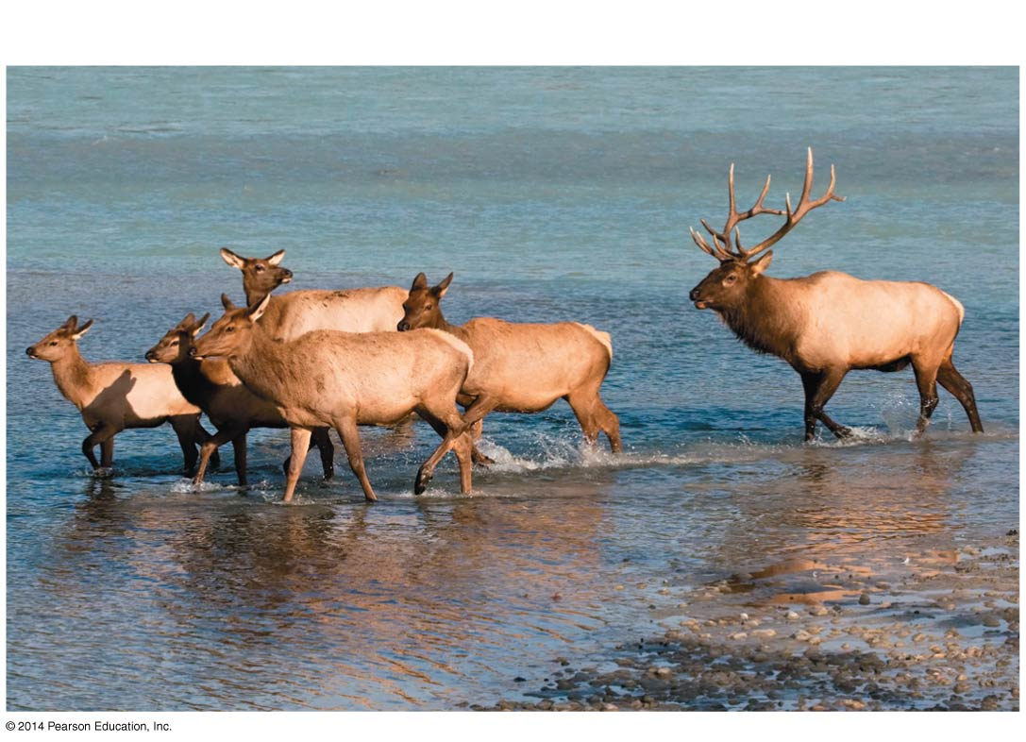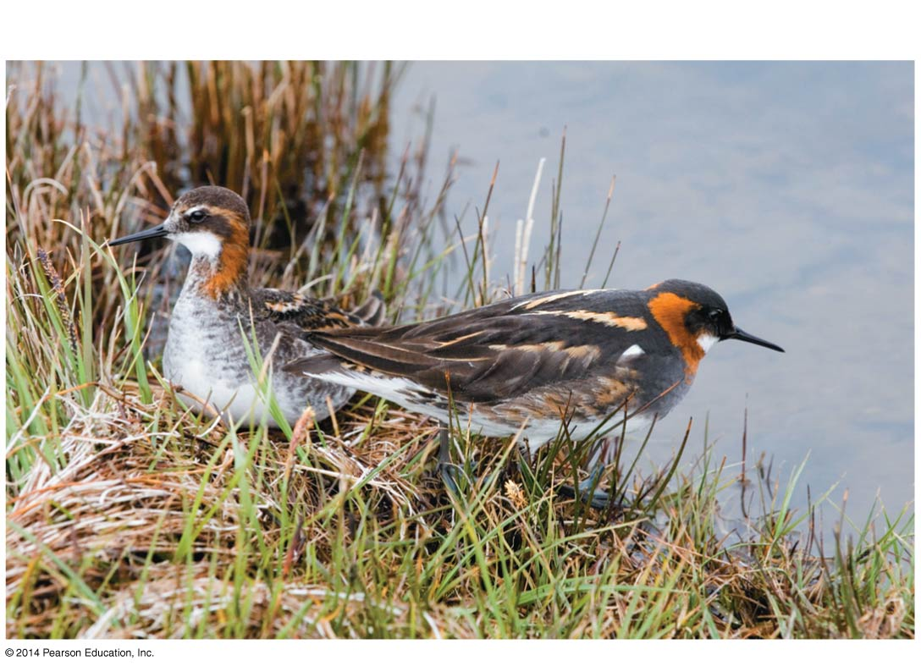

- What is the evolutionary advantage of competition for mates?

- Define and give an example of altruism

- Altruism might initially seem harmful to survival. How does Hamilton’s rule of Kin Selection help to explain the advantage of this behavior?

- Define the following terms and give an example of each

  - Taxis

  - Kinesis
  - Habituation
  - Spatial learning

  - Agonistic behavior

