Name _________________________
AP Biology

Chapter 50- Sensory and Motor Mechanisms

Guided Reading Assignment Campbell’s 10th Edition

Essential Knowledge
None

- Label the three parts of a simple response pathway.


- Describe each part of a pathway in 2-5 words
  - Sensory reception

  - Sensory transduction

  - Transmission

  - Perception

  - Amplification

- Describe the following receptors and give an example of each:
  - Mechanoreceptors-

  - Thermoreceptors-

  - Chemoreceptors-

  - Electromagnetic receptors-

  - Pain receptors-

  - Exteroreceptors-

  - Interoreceptors-

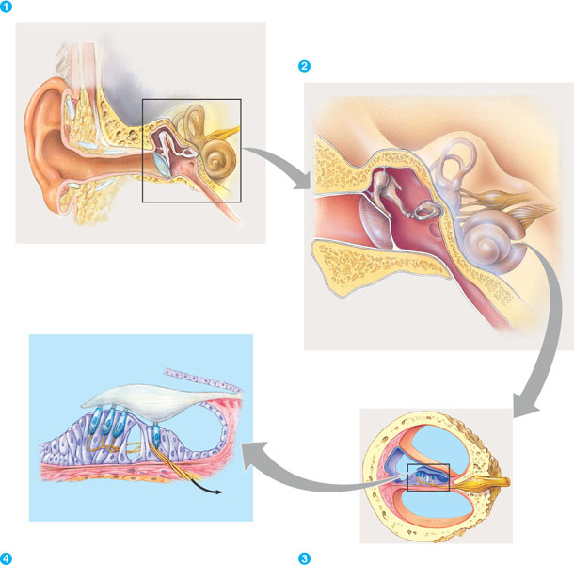
- Use the following figure to discuss the inner working of the human ear:

- Describe the relationship between taste and smell in most organisms.

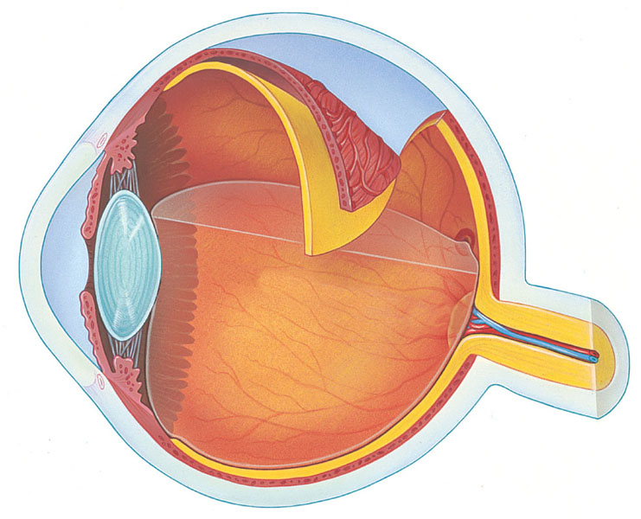

- Label the following diagram of the structure of the vertebrate eye.

- What purposes do the skeleton serve for land mammals?

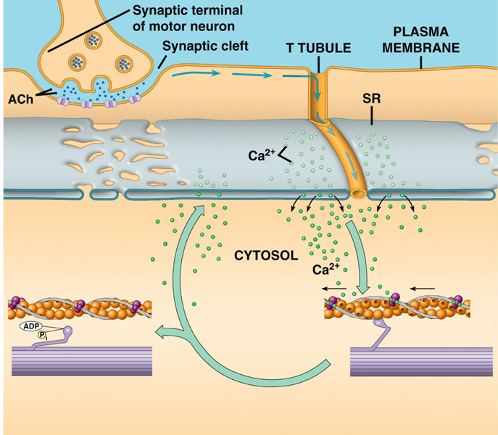

- How does the muscular system interact with the skeletal system to create movement?

- Use the following diagram to explain muscle contraction from the nerve all the way to the roles of actin and myosin.

- Compare and contrast the different types of muscles.

