**Name_________________________**

**AP Biology**

**Chapter 48 – Neurons, Synapses, and Signaling**

**Guided Reading Assignment Campbell’s 10th Edition**

**Essential Knowledge**

3.E.2 Animals have nervous systems that detect external and internal signals, transmit and integrate information, and produce responses

4.A.4 Organisms exhibit complex properties due to interactions between their constituent parts

LO 3.39 The student is able to construct an explanation of how certain drugs affect signal reception and, consequently, signal transduction pathways.

LO 3.45 The student is able to describe how nervous systems transmit information

1. A neuron is the structural unit of the nervous system. Label the neuron

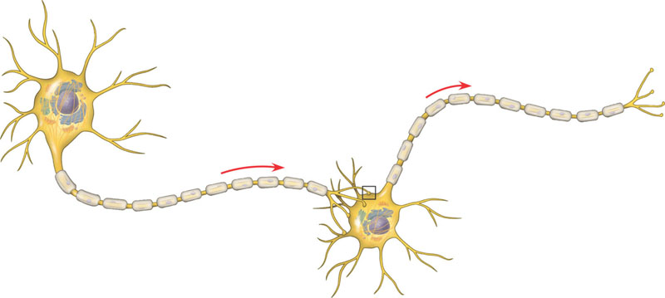

1. What are the three main phases of information processing?

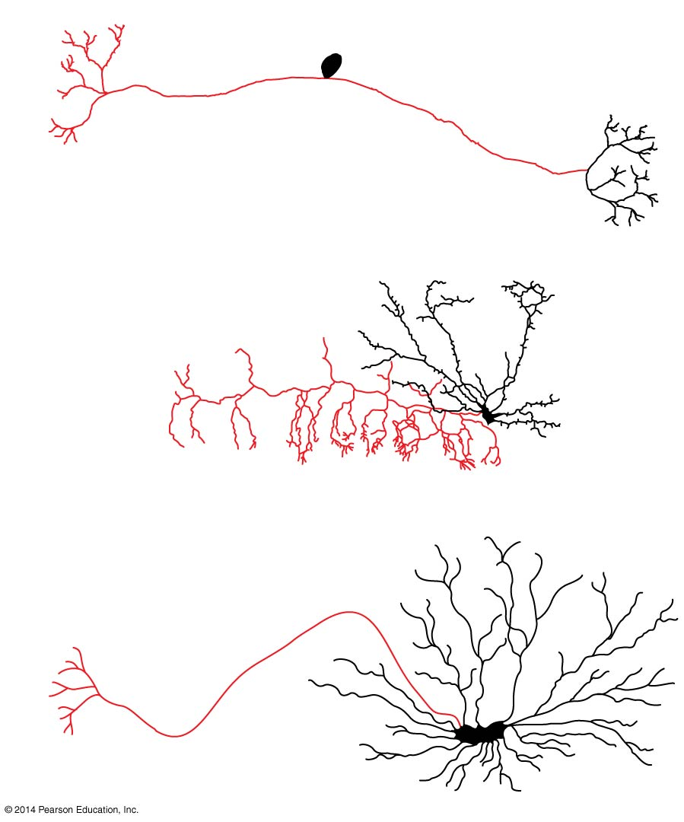

1. Label each type of neuron on the diagram and give a function for each



1. A sodium potassium pump is shown in the diagram. Label the sodium, and the potassium, then draw arrows to show the direction and number of ions moved in and out by the pump.
2. Define the following terms:
   1. Membrane potential
   2. Resting potential
3. Both sodium and potassium are positively charged. How is a membrane potential established by moving them across the membrane?

1. Define the following terms:
   1. Hyperpolarization
   2. Depolarization
   3. Graded potentials
   4. Threshold

Action potential

1. Label the diagram below and explain why myelin is important in nerve conduction.

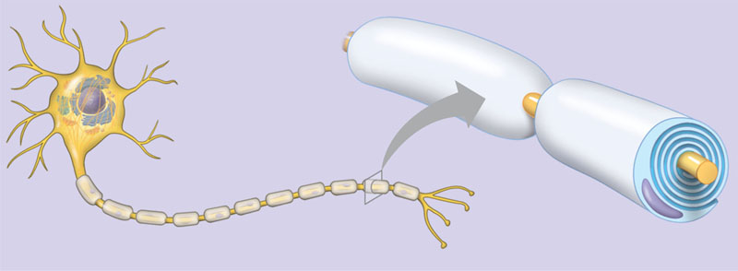

1. Label the diagram below concerning the generation of an action potential.

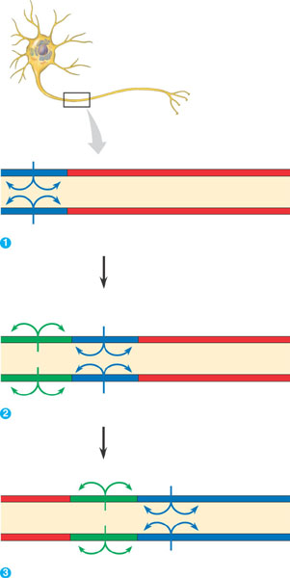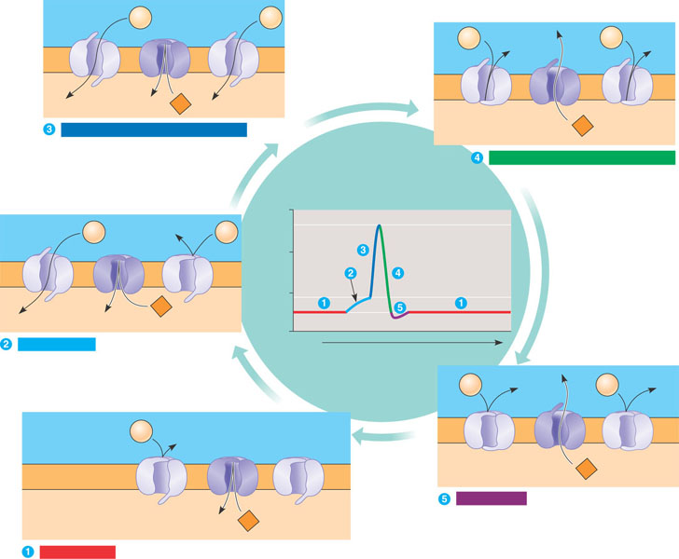

1. How do the various factors affect the speed of an action potential?
   1. Larger axon
   2. Myelination and salutatory conduction
2. Label the diagram demonstrating the conduction of the action potential.
3. What happens at the synaptic cleft?
4. Contrast excitatory and inhibitory postsynaptic potentials.
5. Contrast temporal and spatial summation.
6. Label the diagram of the chemical synapse

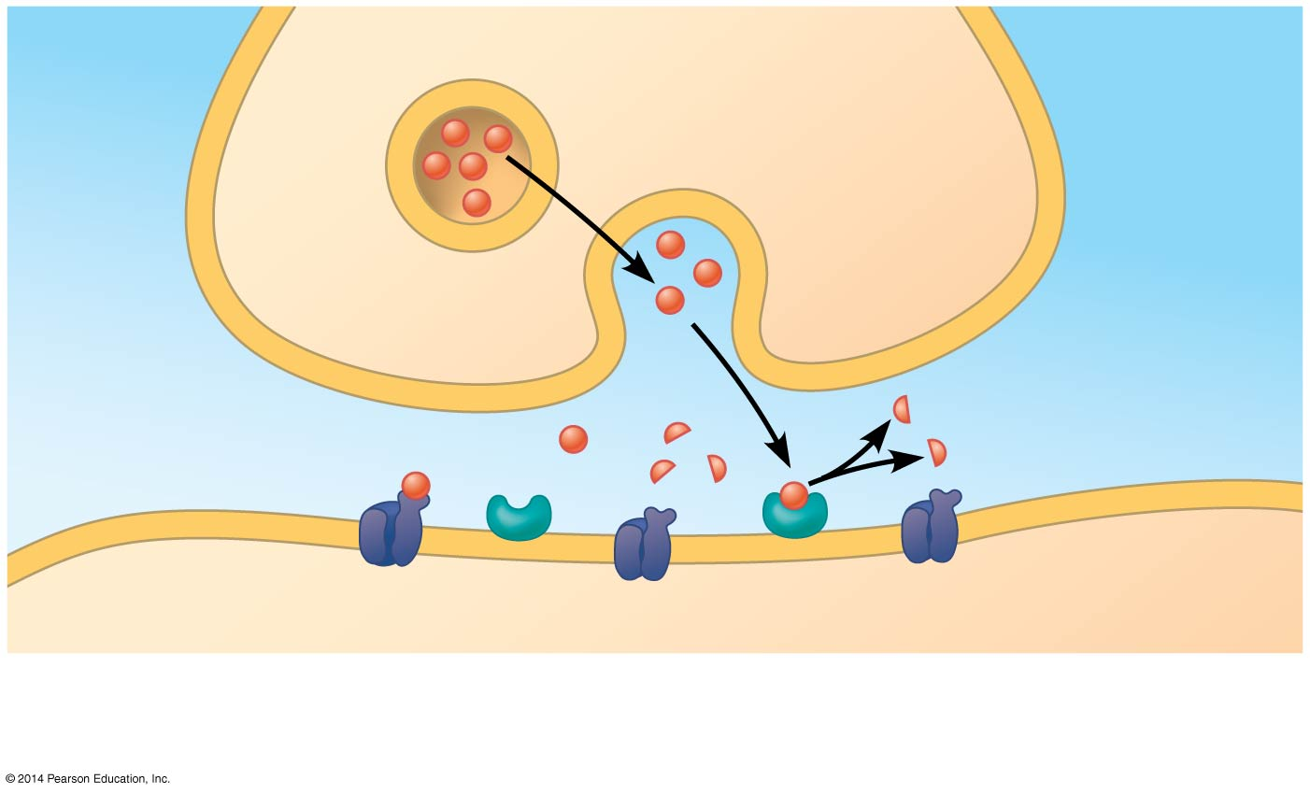

1. What happens when indirect synaptic transmission takes place?
2. Discuss the neurotransmitters listed below:
   1. Acetylcholine
   2. Biogenic amines
      1. Epinephrine and norepinephrine
      2. Dopamine
      3. Serotonin
   3. GABA
   4. Endorphins
   5. Nitrous oxide