Name_________________________
AP Biology
Chapter 47 - Animal Development

Guided Reading Assignment Campbell’s 10th Edition

Essential Knowledge
2.E.1 Timing and coordination of specific events are necessary for the normal development of an organism, and these events are regulated by a variety of mechanisms

LO 2.31 The student can connect concepts in and across domains to show that timing and coordination of specific events are necessary for normal development in an organism and that these events are regulated by multiple mechanisms.
LO 2.32 The student is able to use a graph or diagram to analyze situations or solve problems (quantitatively or qualitatively) that involve timing and coordination of events necessary for normal development in an organism.
LO 2.33 The student is able to justify scientific claims with scientific evidence to show that timing and coordination of several events are necessary for normal development in an organism and that these events are regulated by multiple mechanisms.
LO 2.34 The student is able to describe the role of programmed cell death in development and differentiation, the reuse of molecules, and the maintenance of dynamic homeostasis.

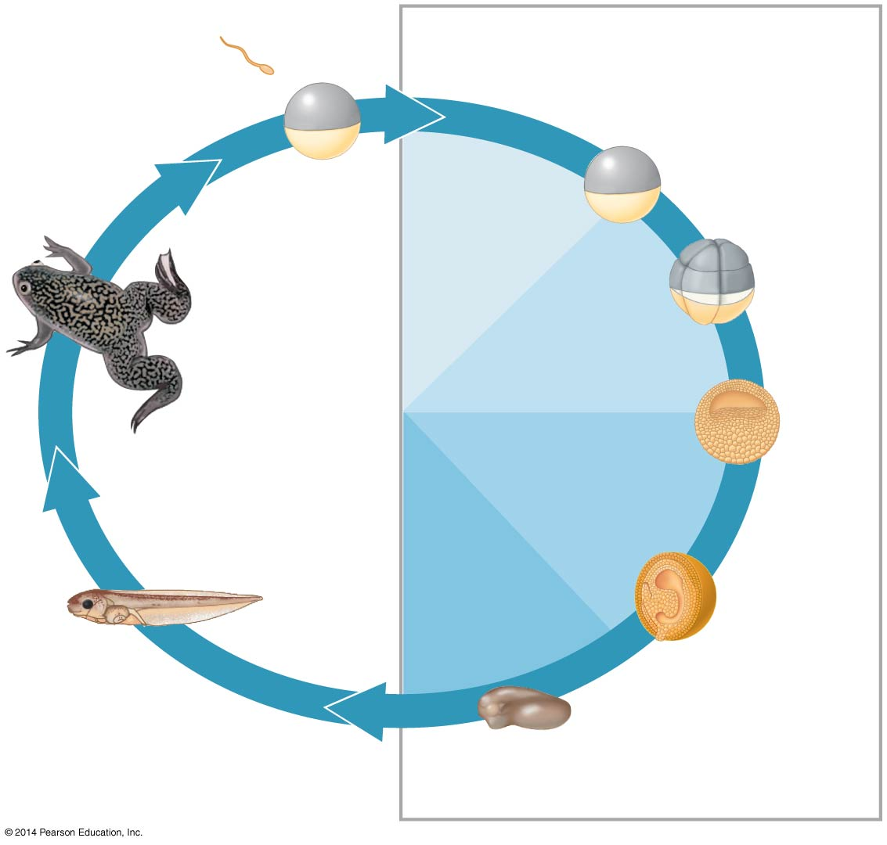
- On the diagram, label the four main events of embryonic development.

- What is the role of fertilization in terms of evolution?

- What steps are taken during fertilization to make sure one egg meets one sperm?

- 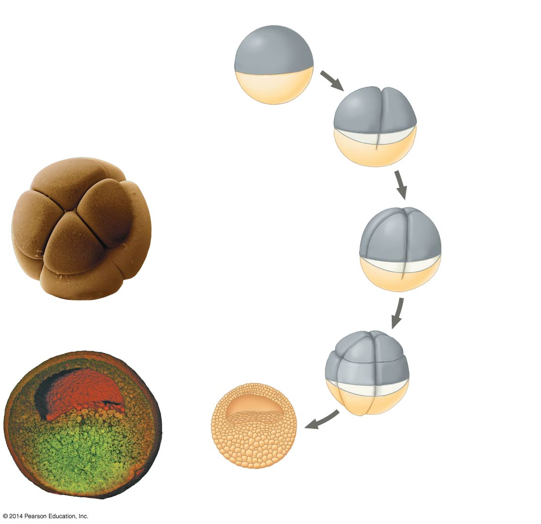Define cleavage and compare the beginning and end of this event

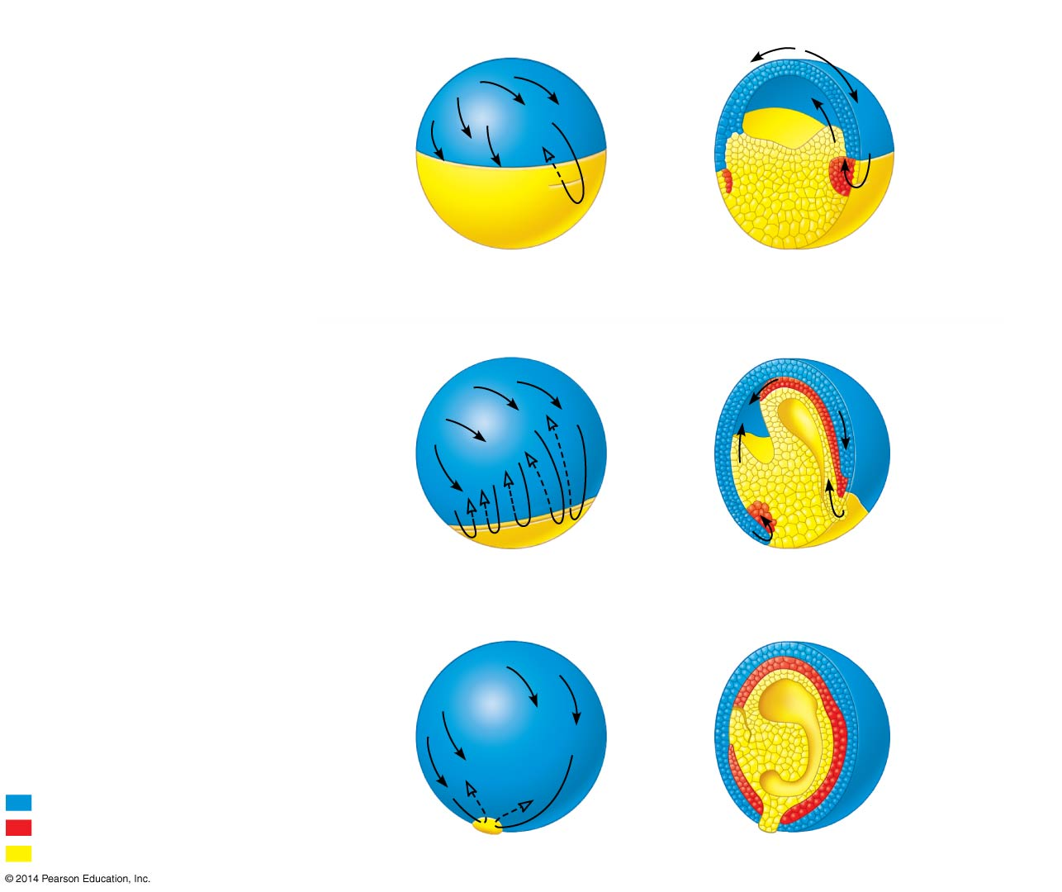
- What happens during gastrulation?

- What three germ cell layers form during gastrulation?

- What is the end result of gastrulation

- 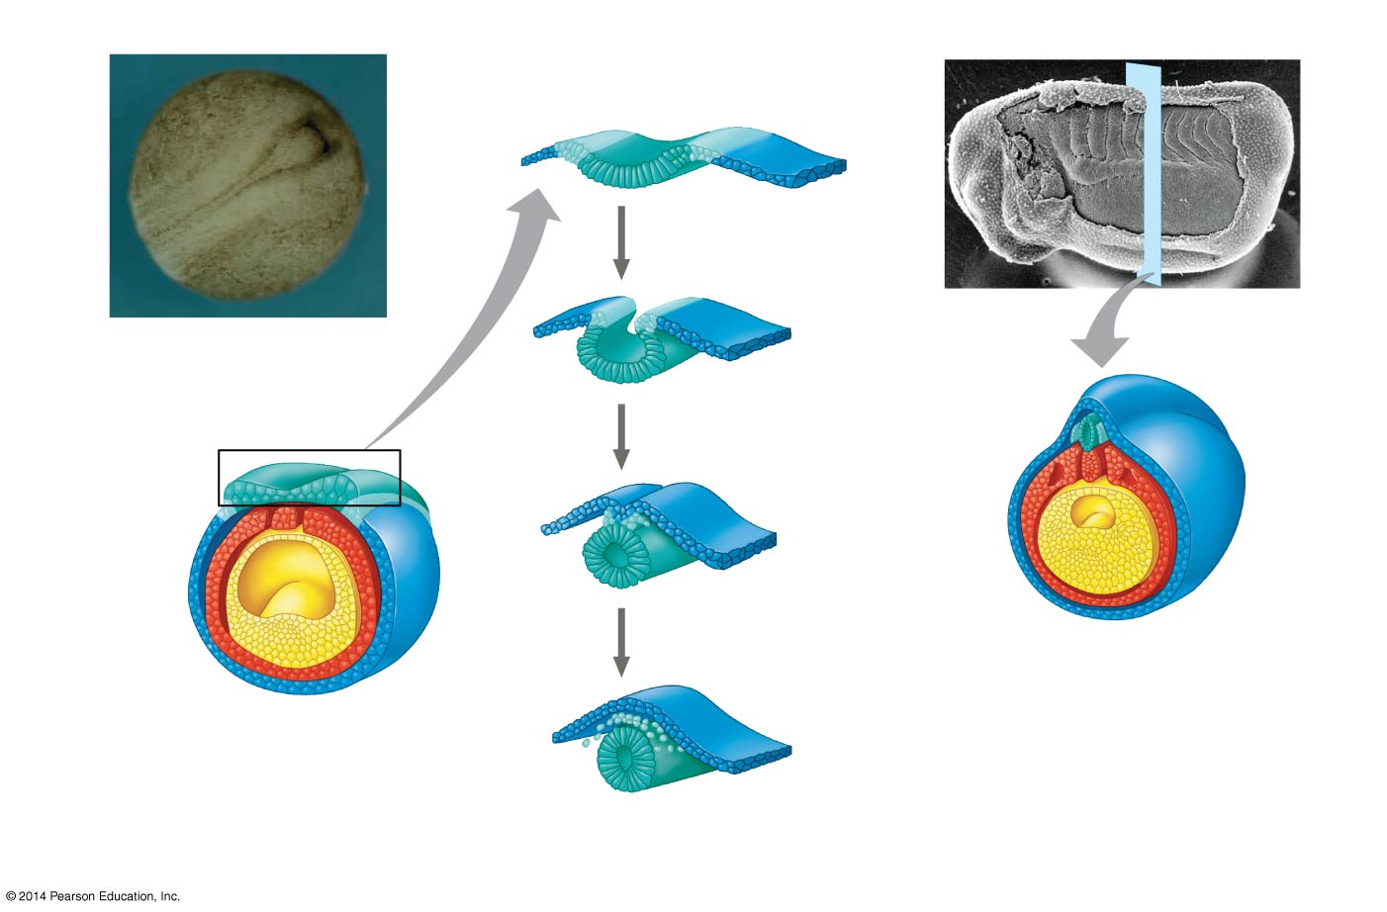What happens during organogenesis?

- Explain neurolation as an example of organogenesis

- What is the role of cell migration in organogenesis?

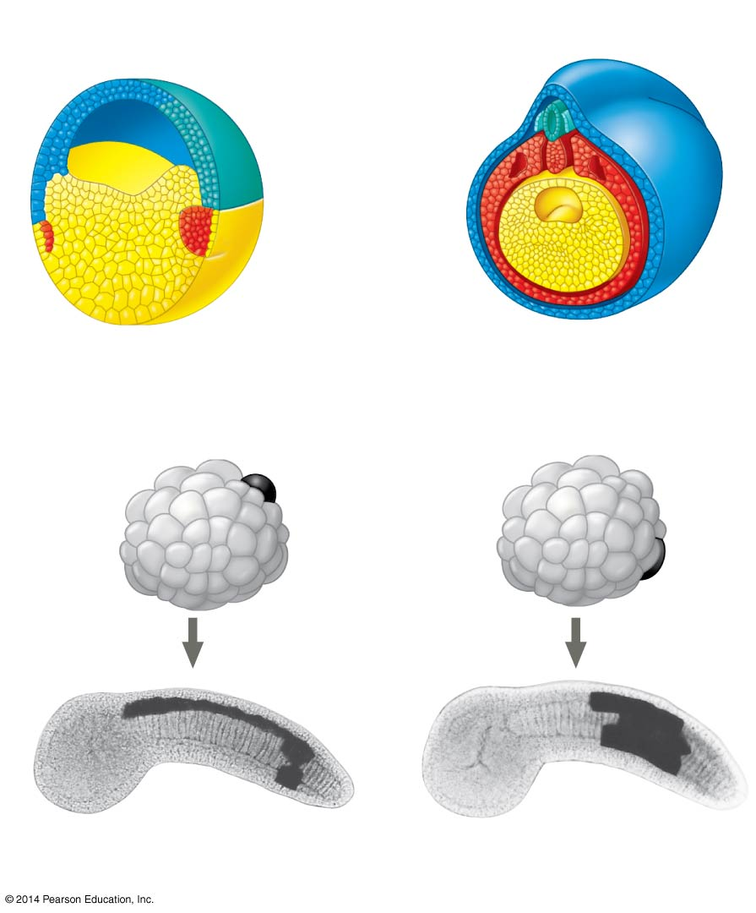

- What would we look like without apoptosis?

- The diagram shows a fate map for a frog embryo. How are such maps constructed?

- What happens to a cell moved from one portion of the developing embryo to another?

- Early cells during development are totipotent, what does this mean?

- As development progresses, how do cells learn of their fate?

- What happens when a signal is received about the fate of a specific cell?

