Name_________________________
AP Biology

Chapter 46 - Animal Reproduction

Guided Reading Assignment Campbell’s 10th Edition

Essential Knowledge
None

LO 3.27 The student is able to compare and contrast processes by which genetic variation is produced and maintained in organisms from multiple domains.

- What are the advantages of asexual reproduction?

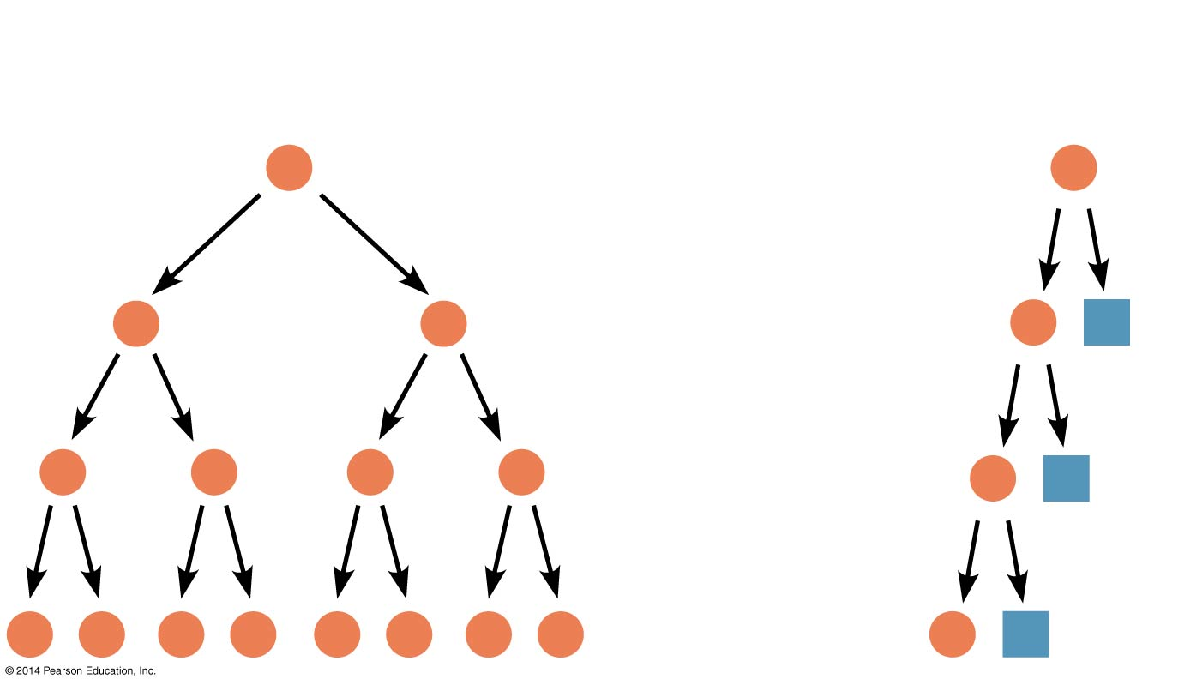
- Under what circumstances is this method most favorable?

- What are the advantages of sexual reproduction?

- Under what circumstances is this method most favorable?

- Why is seasonal reproduction often advantageous?

- What evolutionary problem is solved by hermaphroditism

- Compare and contrast internal and external fertilization.

- What is the site of gametogenesis in human male and females?

- What process produces gametes?

- What is done during gametogenesis to increase genetic variability?

- Why is genetic variability important for sexual reproduction?

- Compare and contrast the two types of mammalian gametogenesis. (oogenesis and spermatogenesis)

