Name _________________________
AP Biology
Chapter 45 - Hormones and the Endocrine System

Guided Reading Assignment Campbell’s 10th Edition

Essential Knowledge
3.B.2 A variety of intercellular and intracellular signal transmissions mediate gene expression
3.D.2 Cell communicate with each other through direct contact with other cells or from a distance via chemical signaling
3.D.1 Cell communication processes share common features that reflect a shared evolutionary history
2.C.1 Organisms use feedback mechanisms to maintain their internal environments and respond to external environmental changes

LO 2.17 The student is able to evaluate data that show the effect(s) of changes in concentrations of key molecules on negative feedback mechanisms.
LO 2.18 The student can make predictions about how organisms use negative feedback mechanisms to maintain their internal environments.
LO 2.19 The student is able to make predictions about how positive feedback mechanisms amplify activities and processes in organisms based on scientific theories and models.
LO 2.21 The student is able to justify the selection of the kind of data needed to answer scientific questions about the relevant mechanism that organisms use to respond to changes in their external environment.
LO 2.42 The student is able to pose a scientific question concerning the behavioral or physiological response of an organism to a change in its environment.
LO 3.34 The student is able to construct explanations of cell communication through cell-to-cell direct contact or through chemical signaling.
LO 3.35 The student is able to create representation(s) that depict how cell-to-cell communication occurs by direct contact or from a distance through chemical signaling..
- 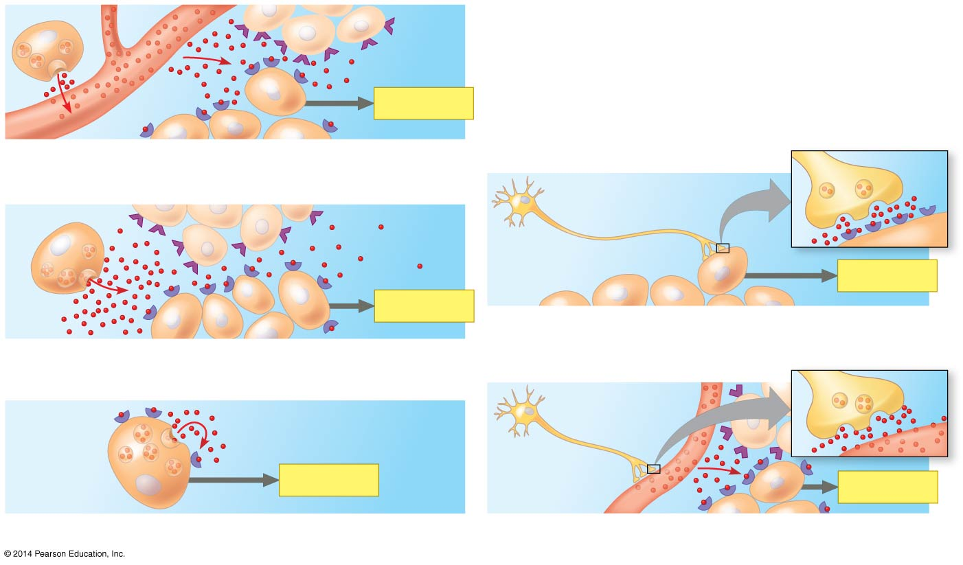Which other system is most closely associated with the endocrine system?

- Use the diagram to label each type of signal

- How do endocrine and paracrine glands differ?

- How does the pathway for water-soluble hormones differ from that of lipid-soluble hormones? Label each on the diagrams below.

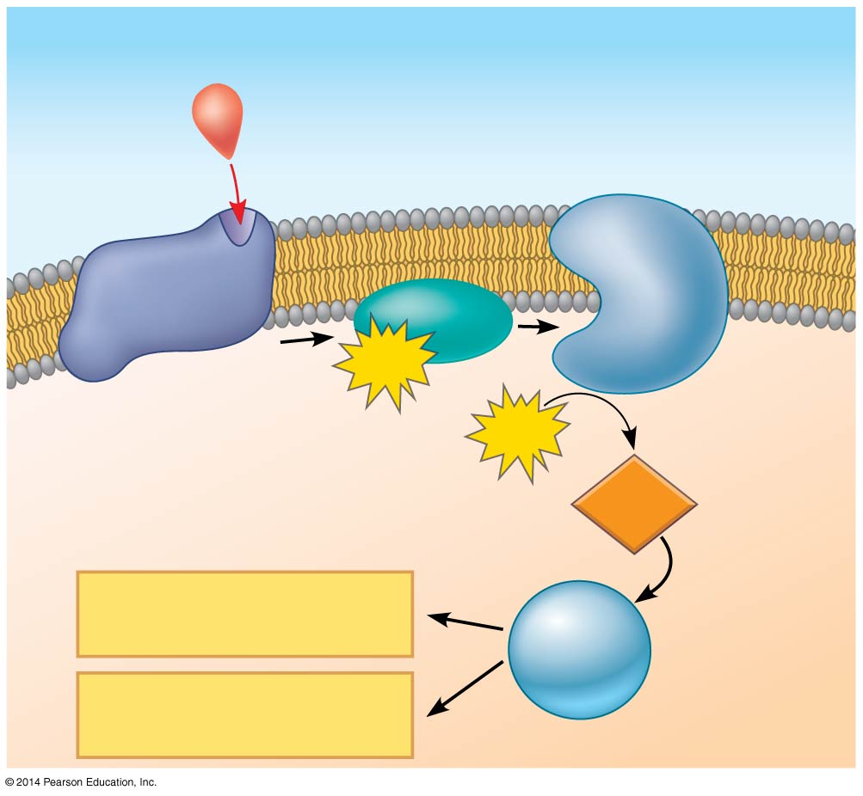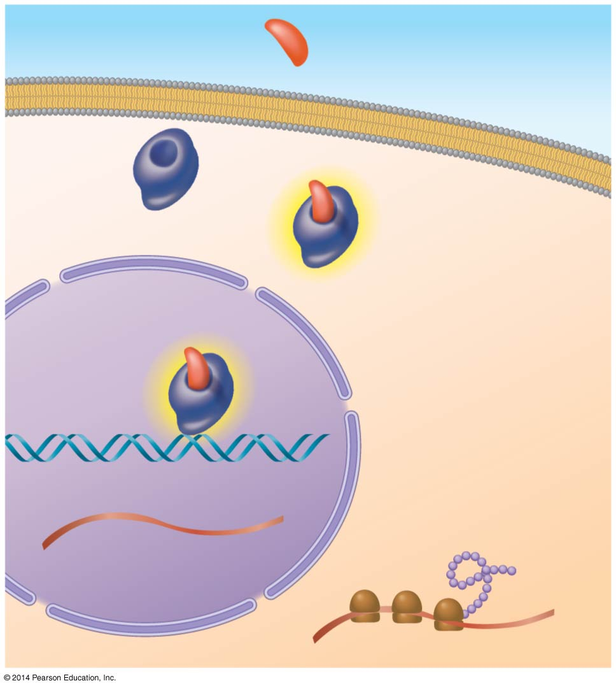

- Review the basics of negative feedback – explain negative feedback using the following terms: receptor, control center, effector, and efferent signal

- What are the three major classes of molecules that function as hormones in vertebrates?

- How can one chemical signal cause different effects?

- What type of molecules are intracellular receptors? Include the why and give an example in your answer.

- Detail the following local regulators.
  - cytokines
b) growth factors
c) nitric oxide
d) prostaglandins

- Study the table on page 999 – it is overwhelming when presented with a long list of information – choose your favorite hormone system to know and understand it in detail. (For example pancreas and insulin/glucagon.) Explain why you chose this one.

- Explain how your favorite system is regulated including feedback, control, hormones and glands.

- Give an example of what happens when this system is broken or fails to be regulated

- Describe how this problem can be treated.

