**Name _________________________**

**AP Biology**

**Chapter 42 - Circulation and Gas Exchange**

**Guided Reading Assignment Campbell’s 10th Edition**

**Essential Knowledge**

None

1. What are the limits to diffusion as a means of transport for living organisms?
2. Compare and contrast open and closed circulatory systems. Be certain focus on advantages of each.

1. Contrast the vertebrate circulatory systems of fish, amphibians, non-avian reptiles and mammals/birds.

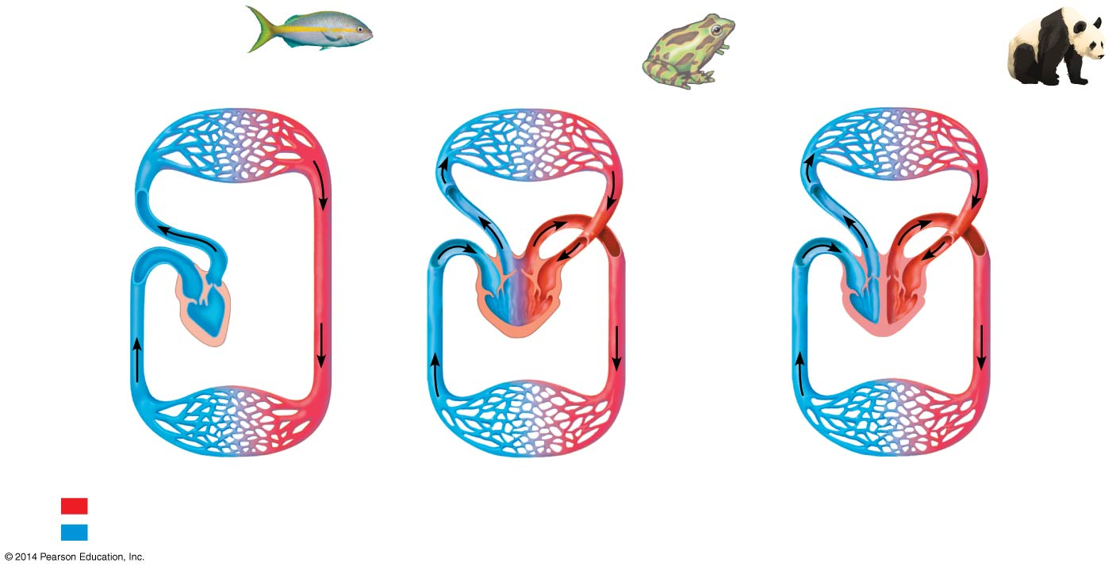

1. What is the main advantage to double circulation?

1. Use the diagram to draw the path of blood through the heart.

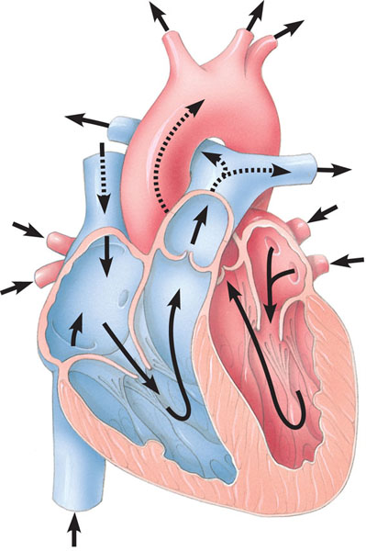

1. Label the diagram below concerning the structure of blood vessels.

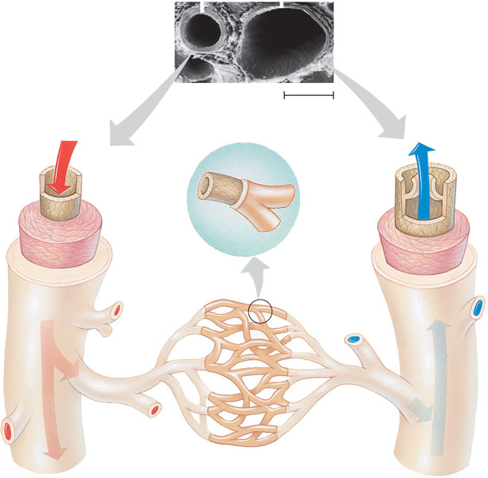

1. How does the law of continuity relate to the velocity of blood flow and what is the relationship between blood pressure, velocity and total cross-sectional area? This is a key concept – why would blood flow slow in a capillary just when you think it will speed up because the capillary is narrow?

1. What is the lymphatic system and why is it important to the circulatory system with regard to blood volume?
2. There are very few examples of positive feedback. Blood clotting is one. Label the diagram below concerning blood clotting.

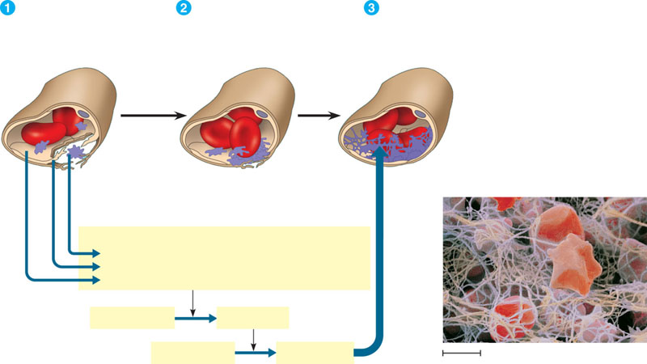

1. Why is gas exchange essential to all living organisms?
2. Considering the rate of diffusion, why is it essential for respiratory surfaces to maximize surface area?

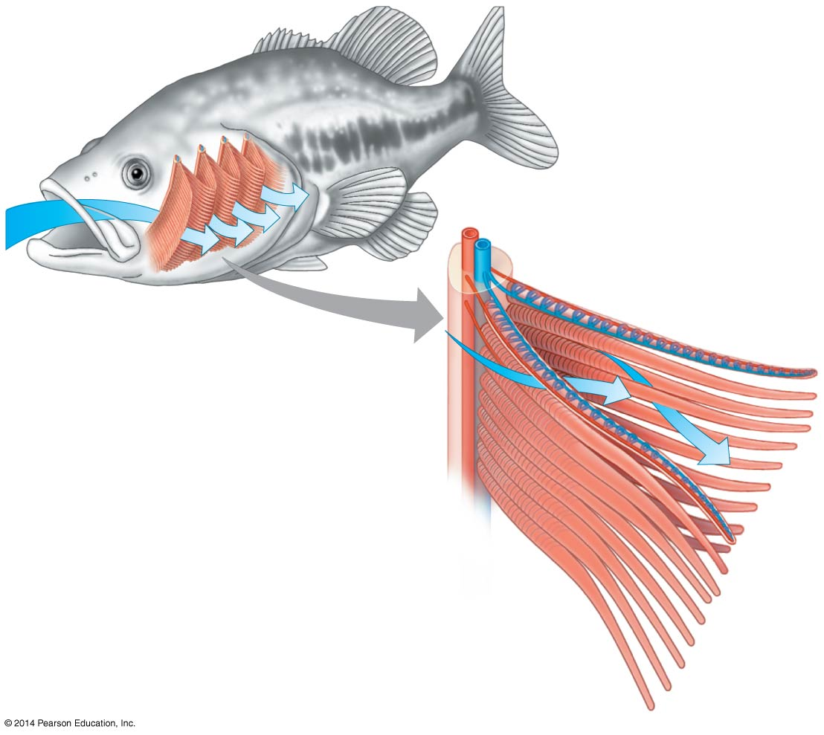

1. What is meant by the term countercurrent exchange and why is it an advantage to animals?
2. How does the tracheal system “work” in insects and why is this an advantage to gas exchange?
3. Why do organisms with lungs require a circulatory system
4. Define the following terms:
   1. Tidal volume
   2. Vital capacity
   3. Residual volume
5. Describe the process of inhalation and exhalation with regard to the contraction of the diaphragm – which is an active process and which is passive?

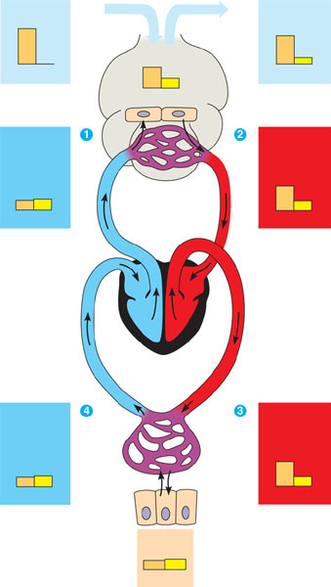

1. The diffusion of oxygen and carbon dioxide is dependent on the partial pressure of the gases – use the diagram to assist in your understanding.
2. What is the relationship between oxygen releasing from hemoglobin and the pH of the blood – why does this make it critical that humans maintain pH within a very strict range?
3. How is carbon dioxide transported? Write the equation of respiration.
4. What is the adaptation of diving mammals that allow them to swim to great depths for very long periods of time?