Name __________________________
AP Biology
Chapter 40 - Animal Form and Function

Guided Reading Assignment Campbell’s 10th Edition

Essential Knowledge
2.A.1 All living systems require constant input of free energy
4.B.2 Cooperative interactions within organisms promote efficiency in the use of energy and matter
2.A.1 All living systems require constant input of free energy
2.C.1 Organisms use feedback mechanisms to maintain their internal environments and respond to external environmental changes
2.D.2 Homeostatic mechanism reflect both common ancestry and divergence due to adaptation in different environments
2.D.3 Biological systems are affected by disruptions to their dynamic homeostasis
2.C.2 Organisms respond to changes in their external environment

LO 2.3 The student is able to predict how changes in free energy availability affect organisms, populations, and/or ecosystems.
LO 2.15 The student can justify a claim made about the effect(s) on a biological system at the molecular, physiological or organismal level when given a scenario in which one or more components within a negative regulatory system is altered.
LO 2.16 The student is able to connect how organisms use negative feedback to maintain their internal environments.
LO 2.19 The student is able to make predictions about how positive feedback mechanisms amplify activities and processes in organisms based on scientific theories and models.
LO 2.20 The student is able to justify that positive feedback mechanisms amplify responses in organisms.
LO 2.21 The student is able to justify the selection of the kind of data needed to answer scientific questions about the relevant mechanism that organisms use to respond to changes in their external environment.
LO 2.35 The student is able to design a plan for collecting data to support the scientific claim that the timing and coordination of physiological events involve regulation.
LO 2.36 The student is able to justify scientific claims with evidence to show how timing and coordination of physiological events involve regulation.
LO 2.37 The student is able to connect concepts that describe mechanisms that regulate the timing and coordination of physiological events.
LO 4.9 The student is able to predict the effects of a change in a component(s) of a biological system on the functionality of an organism(s).
LO 4.10 The student is able to refine representations and models to illustrate biocomplexity due to interactions of the constituent parts.

- Single celled organisms are able to exchange materials directly with the environment. What systems do multicellular organisms use to achieve this goal?

- 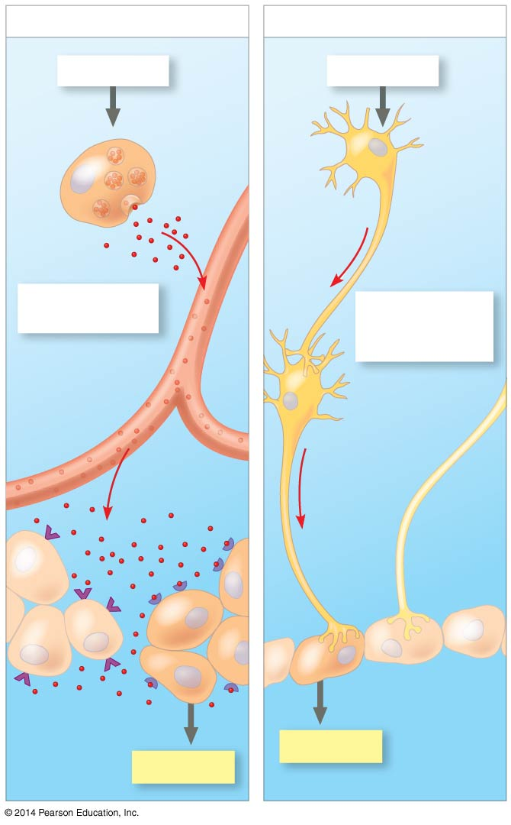Label the diagram and explain how neurons and hormones differ in signaling

- Using the diagram provided, explain how regulators and conformers differ in maintenance of homeostasis
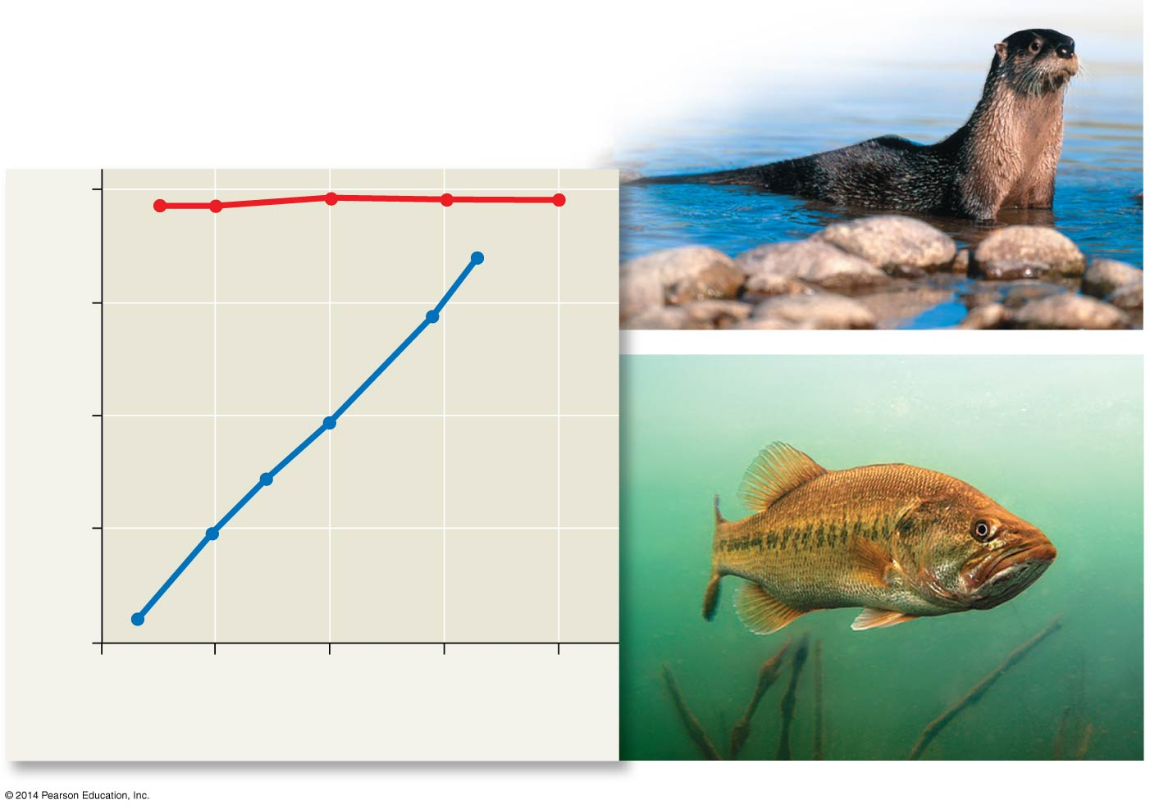

- 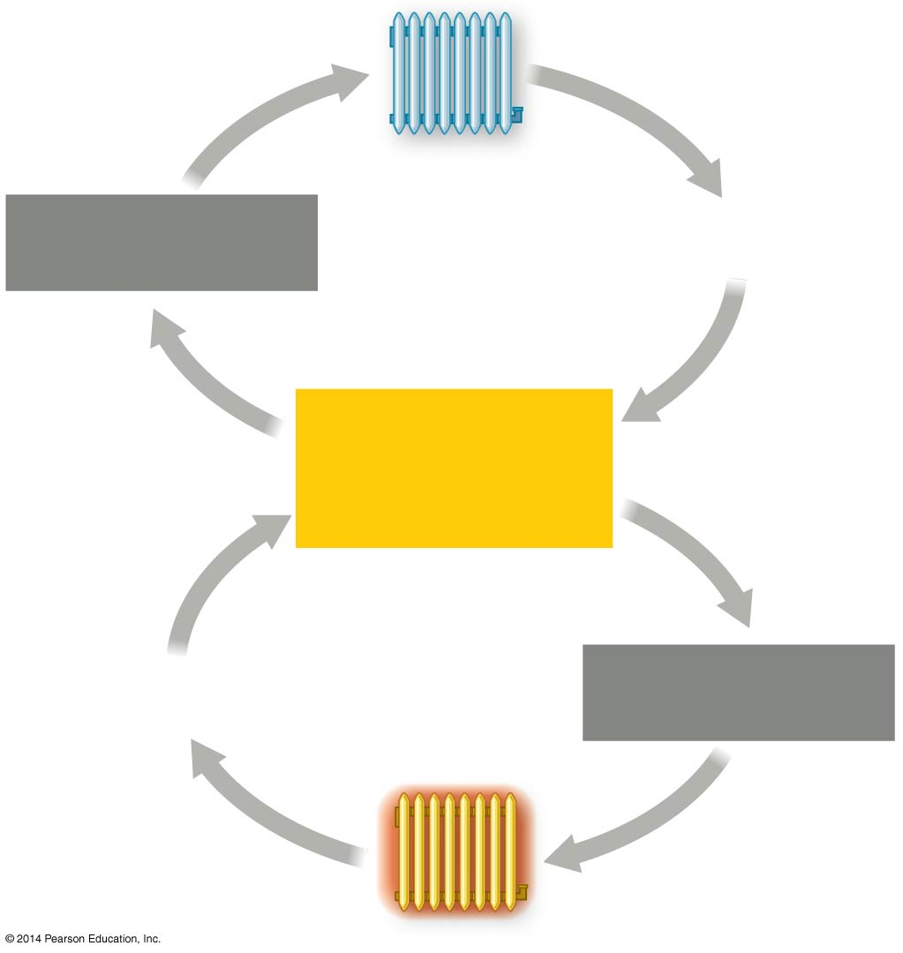Label the diagram, and explain what happens in a room when the temperature is outside of comfortable ranges

  - Too hot

  - Too cold

- How does positive feedback differ from negative feedback?

- Why is it important for feedback loops to have controls in two directions?

- Describe the evolutionary benefit of circadian rhythms

- Define endotherm and give an example

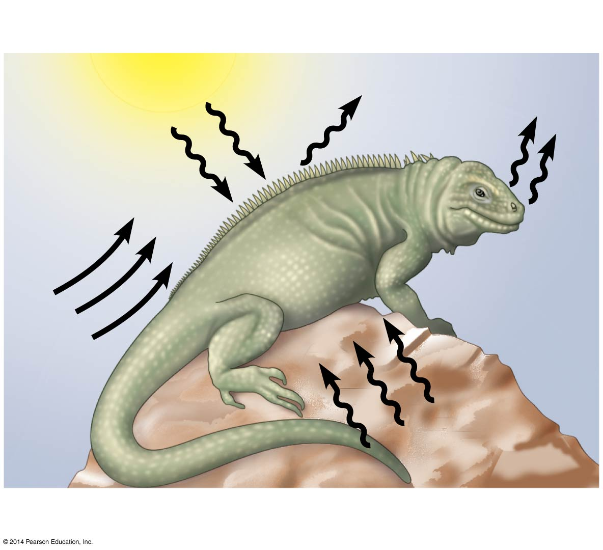

- Define ectotherm and give an example

- What behavioral temperature regulating strategies are being used by the ectotherm in the diagram?

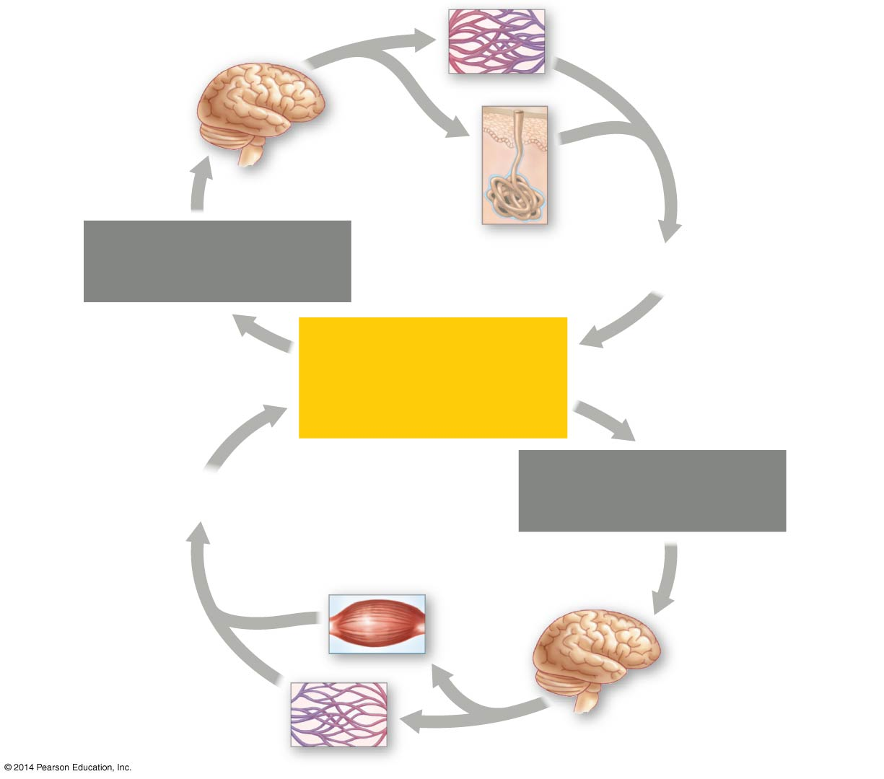

- Label the diagram and describe how humans respond to temperatures that are too hot or too cold

  - Too hot

  - Too cold

- Using the two diagrams below, summarize the relationship between basal metabolic rate and body size.

- Explain why the first graph appears as a straight line while the second graph appears as a logarithmic curve (hint – look at the axes)
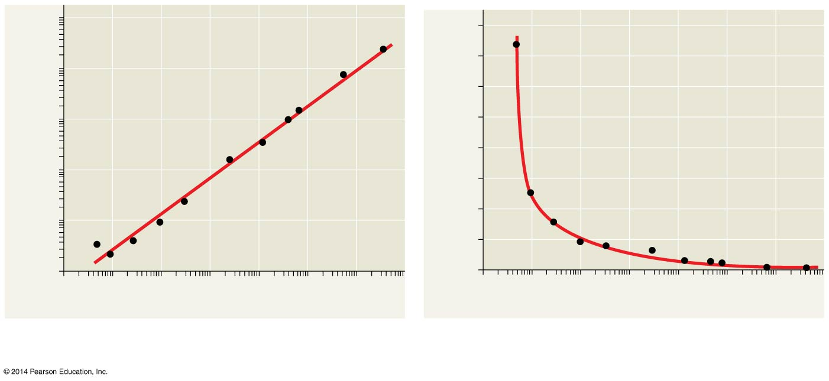

- What is torpor?

- What is the evolutionary advantage of torpor?

