**Name __________________________**

**AP Biology**

**Chapter 28 - Protists**

**Guided Reading Assignment Campbell’s 10th Edition**

**Essential Knowledge**

None

1. What is meant by the statement that Protista Kingdom is paraphyletic?
2. Why is the term protist still used?
3. What is endosymbiosis? What is secondary symbiosis?

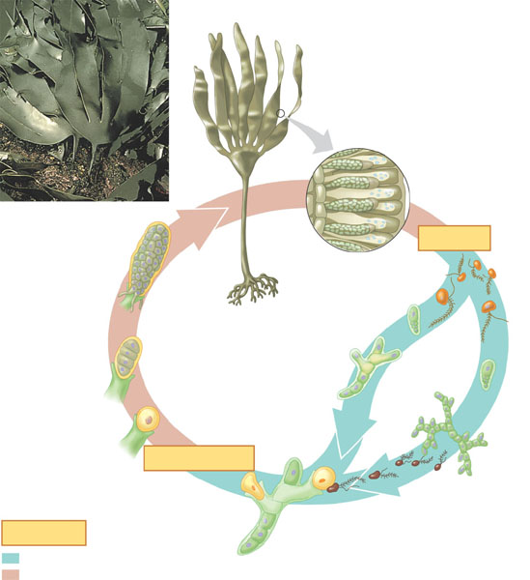

1. What is meant by the term alternation of generations?
2. Label the haploid and diploid phases on the diagram of the life cycle of *Laminaria*.