Name ____________________
AP Biology

Chapter 27 - Guided Reading Bacteria and Archaea

Guided Reading Assignment Campbell’s 10th Edition

Essential Knowledge
3.A.1 DNA, and in some cases RNA, is the primary source of heritable information
3.C.2 Biological systems have multiple processes that increase genetic variation
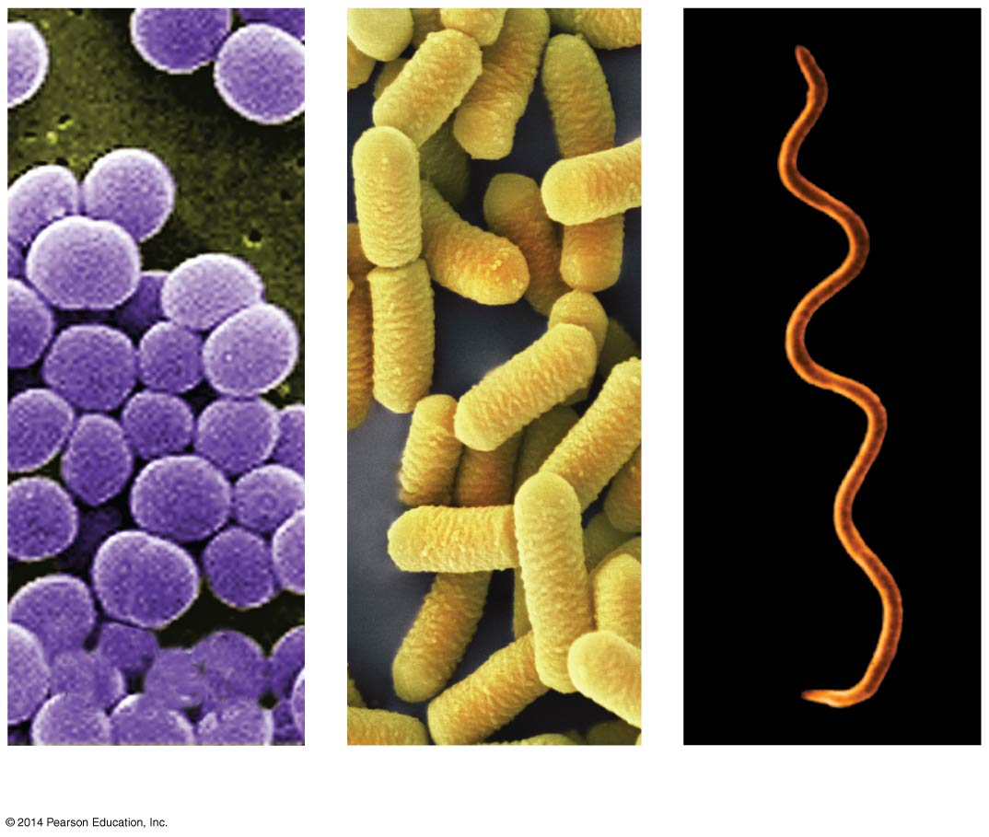
- Label the three most common shapes of prokaryotes shown in the diagram

- How does a cell wall help a prokaryote survive? (three ways)

- Define the following terms:

  - Peptidoglycan

  - Gram-positive

  - Gram-negative

  - Capsule

  - Pili

- Where do prokaryotes store their chromosome?

- What is the purpose of having a plasmid and why is this essential?

- What is the main component of most bacterial genomes?

- Describe the process of binary fission.

- Why is binary fission faster than mitosis?

- What three factors contribute to the high levels of genetic variation in prokaryotes?

- 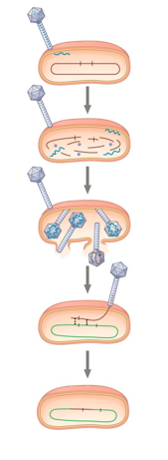Why do mutations make such a large contribution to bacterial genetic variation as compared to humans

- What is the process of alteration of a bacterial cell’s genotype by the uptake of naked, foreign DNA from the surrounding environment?

- What famous experiment in the previous unit described this process?

- Define transduction.

- Label the generalized steps of transduction shown in the diagram.

- 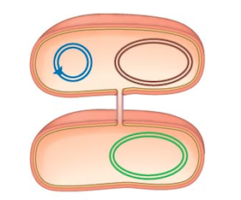What is the process of direct transfer of genetic material (shown in the diagram) between two bacterial cells that are temporarily joined?

- What structure joins them? (label it)

- What is special about the F plasmid?

- What are R plasmids and why are these a problem to humans?

- How does this relate to natural selection?

- What unique characteristics of the Domain Archaea justify its placement separation from bacteria and from eukaryotes?

- List three examples of archaea

