**Name __________________________**

**AP Biology**

**Chapter 26 - Phylogeny and the Tree of Life**

**Guided Reading Assignment Campbell’s 10th Edition**

**Essential Knowledge**

1.B.2 Phylogenetic trees and cladograms are graphical representations (models) of evolutionary history that can be tested

1.D.2 Scientific evidence from many different disciplines supports models of the origin of life

LO 1.14 The student is able to pose scientific questions that correctly identify essential properties of shared, core life processes that provide insights into the history of life on Earth.

LO 1.15 The student is able to describe specific examples of conserved core biological processes and features shared by all domains or within one domain of life, and how these shared, conserved core processes and features support the concept of common ancestry for all organisms.

LO 1.16 The student is able to justify the scientific claim that organisms share many conserved core processes and features that evolved and are widely distributed among organisms today.

LO 1.17 The student is able to pose scientific questions about a group of organisms whose relatedness is described by a phylogenetic tree or cladogram in order to (1) identify shared characteristics, (2) make inferences about the evolutionary history of the group, and (3) identify character data that could extend or improve the phylogenetic tree.

LO 1.18 The student is able to evaluate evidence provided by a data set in conjunction with a phylogenetic tree or a simple cladogram to determine evolutionary history and speciation.

LO 1.19 The student is able create a phylogenetic tree or simple cladogram that correctly represents evolutionary history and speciation from a provided data set.

LO 1.26 The student is able to evaluate given data sets that illustrate evolution as an ongoing process.

This chapter can be a bit difficult as we are extending and learning new ways to view classification. There are those who see the future of taxonomy abandoning the kingdom – phylum – class, etc. system altogether. This chapter introduces classifications with a greater understanding of molecular biology. A study help is in learning the vocabulary at the inception of the unit.

1. Define the following terms:
   1. Phylogeny
   2. Systematics
   3. Taxonomy

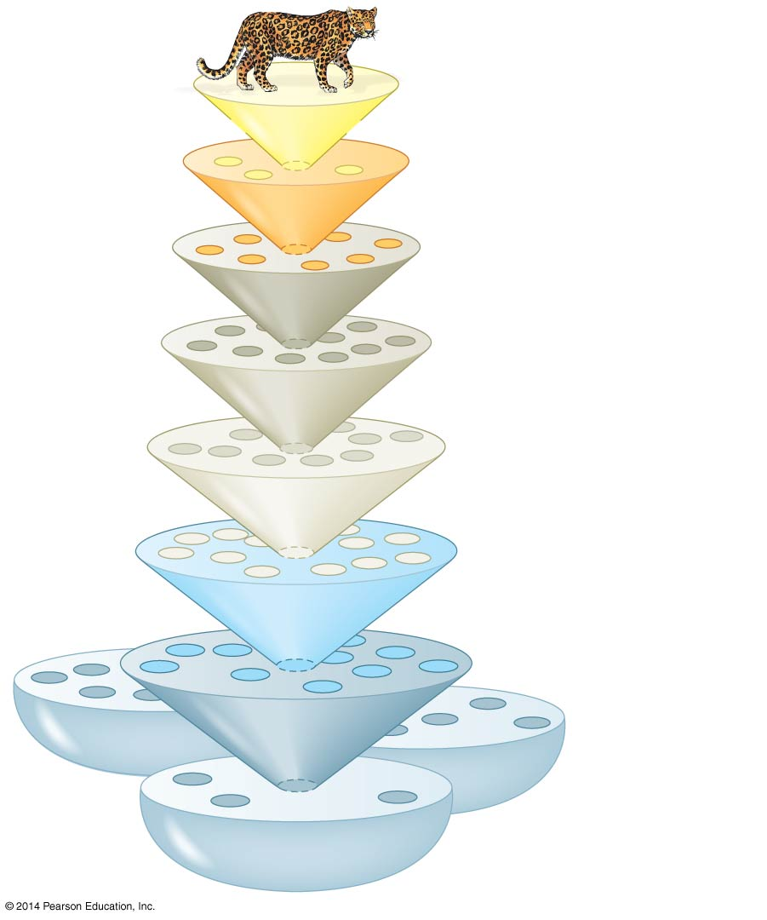

* 1. Binomial nomenclature
  2. Phylogenetic trees
  3. Cladogram

1. Label each level of Linnaean classification on the diagram
2. What information is used to construct a phylogenetic tree?
3. Use the following blank diagram to compare and explain monophyletic, paraphyletic and polyphyletic – include the definition of each term in your diagram

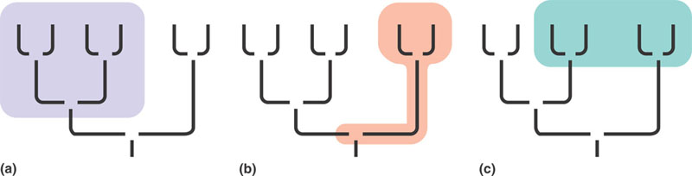

1. What is the relationship between the ingroup and the outgroup in classification?
2. Explain how shared characteristics shown in the data table below were used to construct this phylogenetic tree.

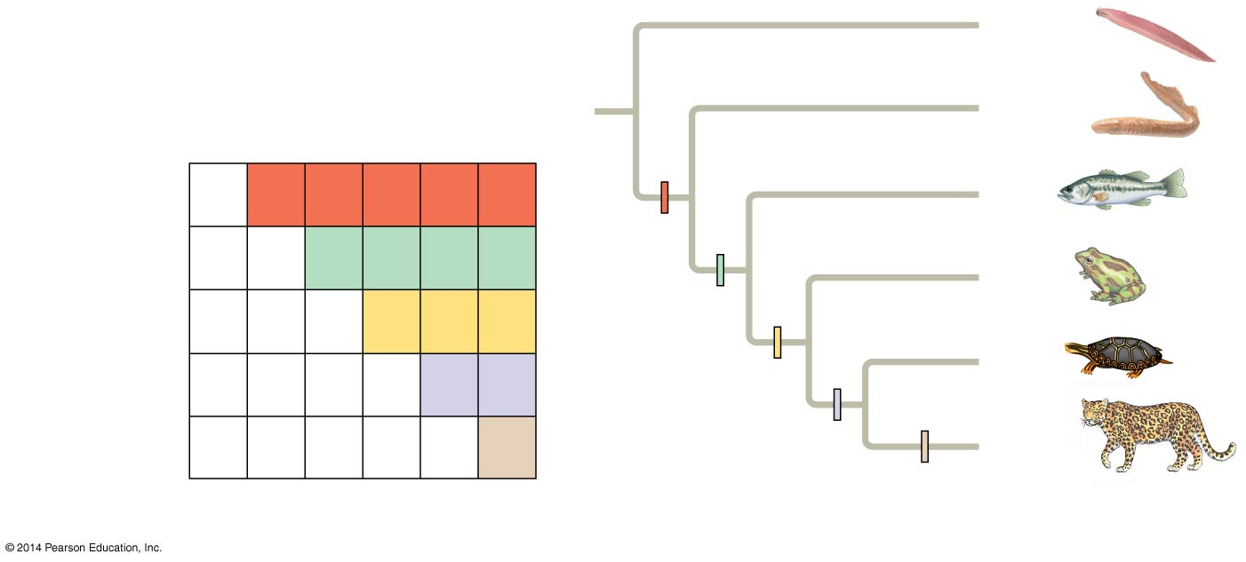

1. What does each branching point on the tree represent?
2. What is the difference in the meaning between the lengths of lines in a tree?
3. Look up the term parsimony in a dictionary and write its definition here:

1. How is this applied to understanding evolution – what is the principle of maximum parsimony and the principle of maximum likelihood?
2. What is the concept of a molecular clock and how is it useful?

1. How many kingdoms did Linnaeus use in his first classification system?
2. What domains have been agreed upon today? On what evidence were these changes made?