Name __________________________
AP Biology
Chapter 25 - The History of Life on Earth

Guided Reading Assignment Campbell’s 10th Edition

Essential Knowledge
1.B.1 Organisms share many conserved core processes and features that evolved and are widely distributed among organisms today
1.D.1 There are several hypotheses about the natural origin of life on Earth, each with supporting evidence
1.A.4 Biological evolution is supported by scientific evidence from many disciplines, including mathematics
1.C.1 Speciation and extinction have occurred throughout the Earth's history
1.B.1 Organisms share many conserved core processes and features that evolved and are widely distributed among organisms today
1.D.1 There are several hypotheses about the natural origin of life on Earth, each with supporting evidence
4.B.3 Interaction between and within populations influence patterns of species distribution and abundance
2.E.1 Timing and coordination of specific events are necessary for the normal development of an organism, and these events are regulated by a variety of mechanisms

LO 1.20 The student is able to analyze data related to questions of speciation and extinction throughout the Earth’s history.
LO 1.21 The student is able to design a plan for collecting data to investigate the scientific claim that speciation and extinction have occurred throughout the Earth’s history.
LO 1.27 The student is able to describe a scientific hypothesis about the origin of life on Earth.
LO 1.28 The student is able to evaluate scientific questions based on hypotheses about the origin of life on Earth
LO 1.29 The student is able to describe the reasons for revisions of scientific hypotheses of the origin of life on Earth.
LO 1.30 The student is able to evaluate scientific hypotheses about the origin of life on Earth.
LO 1.31 The student is able to evaluate the accuracy and legitimacy of data to answer scientific questions about the origin of life on Earth.
LO 1.32 The student is able to justify the selection of geological, physical, and chemical data that reveal early Earth conditions.

- Define the following

  - Protobionts -

b. Ribozymes -

c. Radiometric Dating -

d. Half-life -

e. Magnetic Reversals -

f. Geologic Record -

g. Stromatolites -

h. Serial Endosymbiosis -

k. Pangea -

l. Three Domain System -

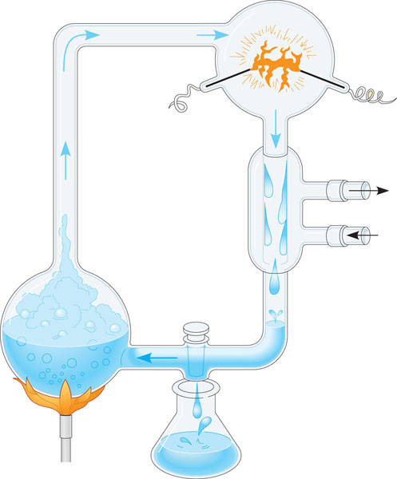
- How old is the Earth?

- What did Oparin and Haldane hypothesize

- Use the diagram to describe and explain Urey and Miller’s 1953 experiment tested the Oparn and Haldane hypothesis

4. Where were the first organic compounds on Earth probably formed?

5. Explain why RNA developed before DNA

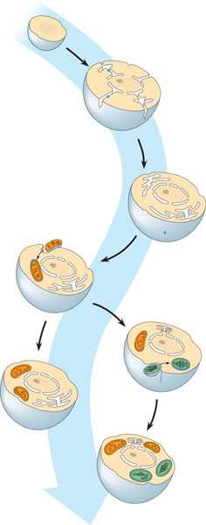

6. What did the atmosphere of early Earth primarily consist of?

7. Use the diagram to help explain serial endosymbiosis.

8. Mitochondria and plastids likely formed in eukaryotes in what way?

9. Use the diagram below to label the 5 major mass extinctions, and if possible give a brief reason for each.
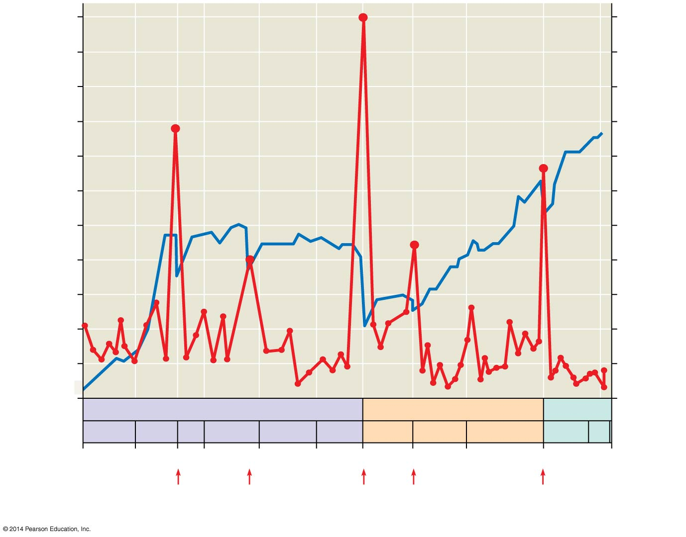

10. During which period are we currently living?

11. How did early prokaryotes evolve and change early Earth?

12. Name several traits of the first prokaryotes.

13. When did the first prokaryotes exist on Earth?

