**Name __________________________**

**AP Biology**

**Guided Reading Chapter 23 - The Evolution of Populations**

**Guided Reading Assignment Campbell’s 10th Edition**

**Essential Knowledge**

1.A.2 Natural selection acts on phenotypic variations in populations

4.C.3 The level of variation in a population affects population dynamics

1.A.1 Natural selection is a major mechanism of evolution

4.C.4 The diversity of species within an ecosystem may influence the stability of the ecosystem

1.A.3 Evolutionary change is also driven by random processes

3.C.1 Biological systems have multiple processes that increase genetic variation

LO 1.1 The student is able to convert a data set from a table of numbers that reflect a change in the genetic makeup of a population over time and to apply mathematical methods and conceptual understandings to investigate the cause(s) and effect(s) of this change.

LO 1.2 The student is able to evaluate evidence provided by data to qualitatively and/or quantitatively investigate the role of natural selection in evolution.

LO 1.3 The student is able to apply mathematical methods to data from a real or simulated population to predict what will happen to the population in the future.

LO 1.4 The student is able to evaluate data-based evidence that describes evolutionary changes in the genetic makeup of a population over time.

LO 1.5 The student is able to connect evolutionary changes in a population over time to a change in the environment.

LO 1.6 The student is able to use data from mathematical models based on the Hardy-Weinberg equilibrium to analyze genetic drift and effects of selection in the evolution of specific populations

LO 1.7 The student is able to justify the selection of data from mathematical models based on the Hardy-Weinberg equilibrium to analyze genetic drift and the effects of selection in the evolution of specific populations.

LO 1.8 The student is able to make predictions about the effects of genetic drift, migration and artificial selection on the genetic makeup of a population.

LO 1.9 The student is able to evaluate evidence provided by data from many scientific disciplines that support biological evolution.

LO 1.13 The student is able to construct and/or justify mathematical models, diagrams or simulations that represent processes of biological evolution.

LO 1.25 The student is able to describe a model that represents evolution within a population.

LO 3.24 The student is able to predict how a change in genotype, when expressed as a phenotype, provides a variation that can be subject to natural selection.

LO 3.26 The student is able to explain the connection between genetic variation in organisms and phenotypic variation in populations.

LO 4.26 The student is able to use theories and models to make scientific claims and/or predictions about the effects of variation within populations on survival and fitness.

1. What is the smallest using of evolution and why is this important to understand?
2. Define the following terms:
   1. Microevolution
   2. Population
   3. Population genetics
   4. Gene pool

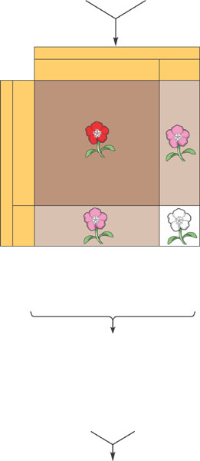

1. What is the Hardy-Weinberg Theorem and why does it appear to be an apparent contradiction to evolution?
2. What is Hardy-Weinberg equilibrium?
3. Use the blank diagram below to relate the H-W equation to a Punnett square.
4. What are the **five conditions** for H-W equilibrium to be maintained?
5. How can the H-W equation be used to today in terms of human health?
6. What are the two broad processes that make evolution possible?

1. What is the impact of the following:
   1. Point mutation
   2. Gene duplication
   3. Sexual recombination
2. What is the relationship between mutation rates and generation span?

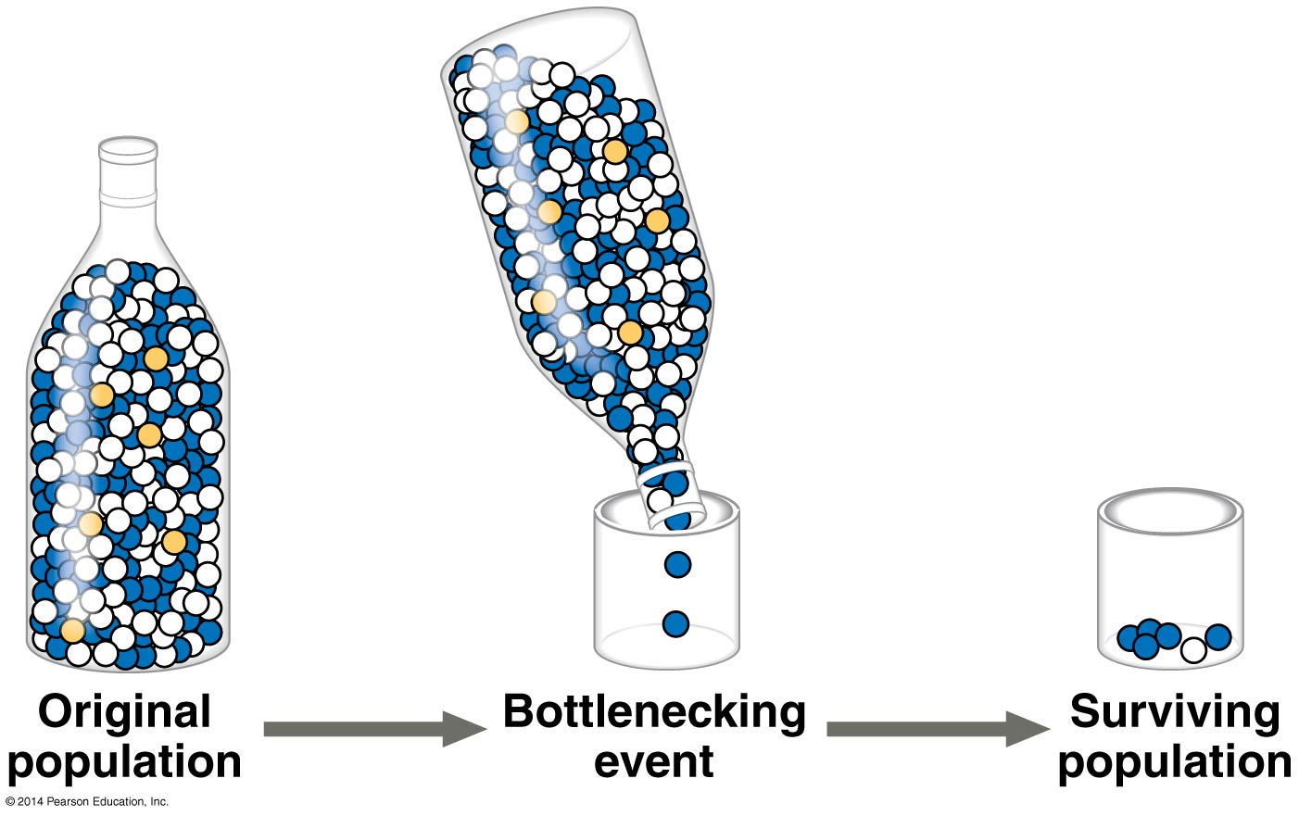

1. Define the following:
   1. Genetic drift
   2. Bottleneck effect
   3. Founder effect
   4. Gene flow
2. Why would we discuss adaptive evolution and what role does natural selection play?
3. Give examples of phenotypical variation that is not inheritable.
4. Explain the terms phenotypic polymorphism and genetic polymorphism in common terms giving an example from your own experience. I will be looking for a reasonable answer for this question – points will be deducted if not answered.
5. How do we measure genetic variation?

1. How can very small differences in nucleotide sequences lead to such diversity in the human population?
2. What is geographic variation and how does the term cline relate?
3. What is different about the terms fitness and relative fitness?
4. Why is it said that evolution acts on phenotypes and not genotypes?

1. Use the diagram below to differentiate between the modes of selection.

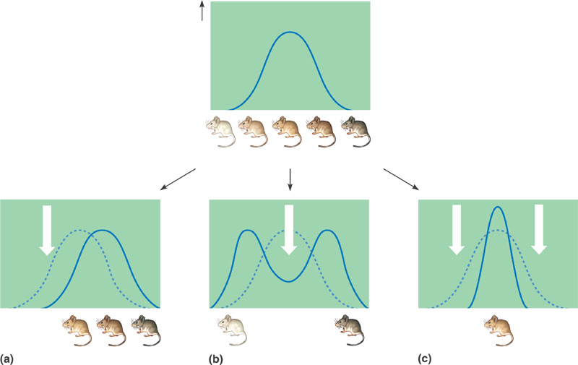

1. Why does diploidy preserve genetic variation?

1. How does balancing natural selection relate to the term balanced polymorphism?

1. Define and give an example of the following:
   1. Heterozygote advantage
   2. Frequency dependent selection
   3. Neutral variation
   4. Sexual dimorphism
   5. Intrasexual selection
   6. Intersexual selection
2. What are the limitations to Natural Selection?
3. **Complete text Investigation 23.1 “How can the frequency of alleles be calculated?” through online text under Concept 23.1 heading – copy your data table with headings and answer questions 1-4 of the activity using complete sentences that EXPRESS a complete thought.**