Name ___________________________
AP Biology
Chapter 22 Descent with Modification: A Darwinian View of Life

Guided Reading Assignment Campbell’s 10th Edition

Essential Knowledge
1.A.1 Natural selection is a major mechanism of evolution
1.A.4 Biological evolution is supported by scientific evidence from many disciplines, including mathematics

LO 1.10 The student is able to refine evidence based on data from many scientific disciplines that support biological evolution.
LO 1.12 The student is able to connect scientific evidence from many scientific disciplines to support the modern concept of evolution.
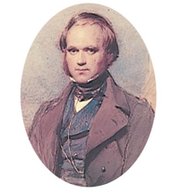
- What were the two major points of Darwin’s publication “The Origin of Species”?
- Define the following terms:
  - Natural selection
  - Evolutionary adaptation
  - Evolution
  - Taxonomy
- Detail the impact/position/contribution to evolutionary theory and include a perspective of time in the following:
  - Aristotle
  - Linnaeus
  - Cuvier
  - Lyell
  - Lamarck
  - Malthus
  - Hutton
- How does catastrophism relate to the ideas of gradualism?
- How did the Voyage of the Beagle impact Darwin’s research?
- How did Alfred Wallace impact Darwin in his work?
- What part did adaptation play in Darwin’s thinking?
- What did Darwin mean by descent with modification?
- How did the concept of artificial selection impact Darwin’s ideas?
- What three word phrase summarizes Darwin’s mechanism of evolution?
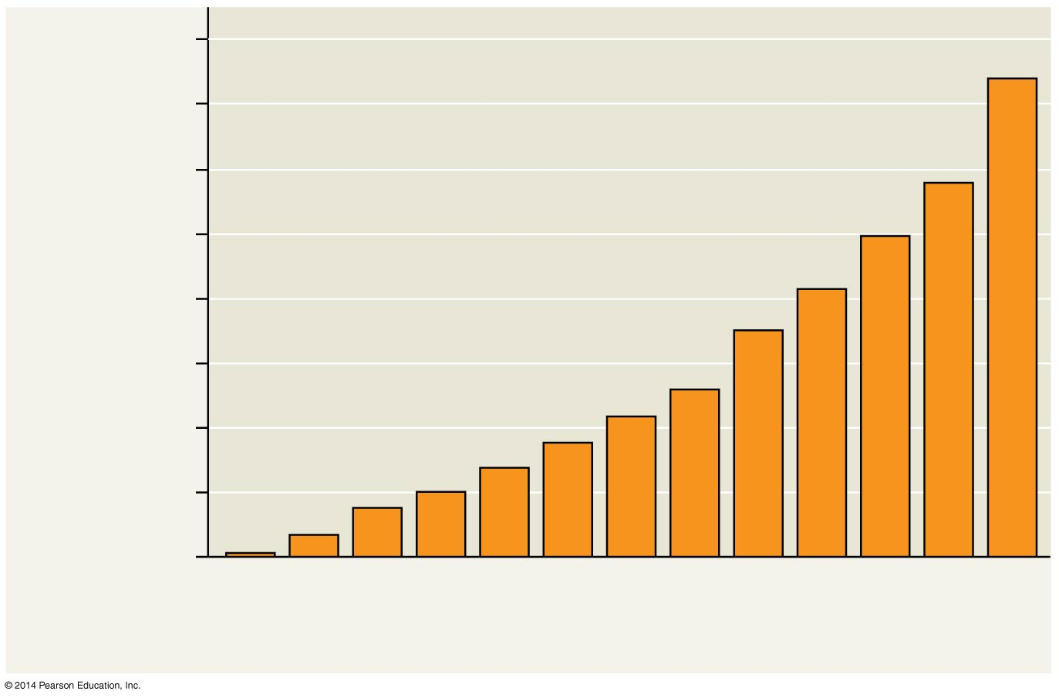

- Explain the evolution of Drug Resistance in bacteria in terms of natural selection.
- 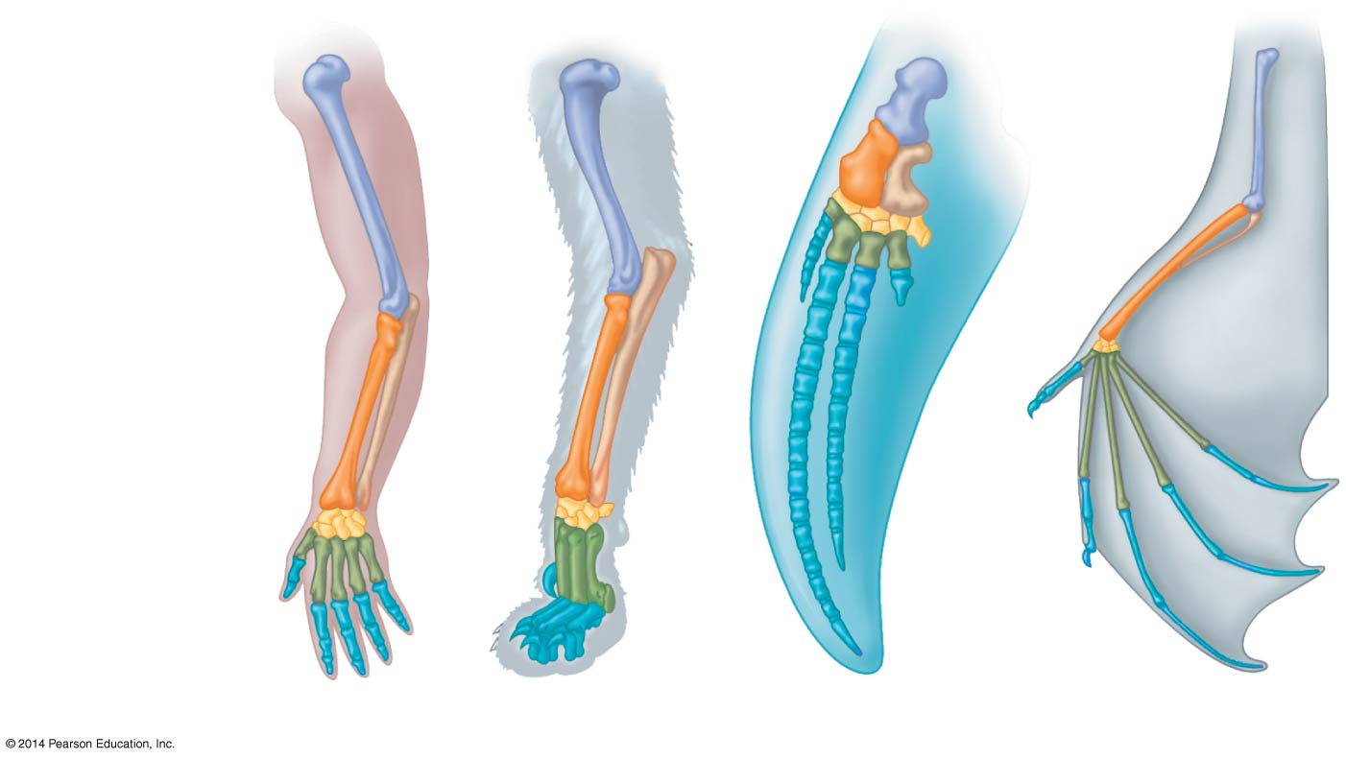 Define the following terms:
  - Homologous structures
  - Vestigial structures
  - 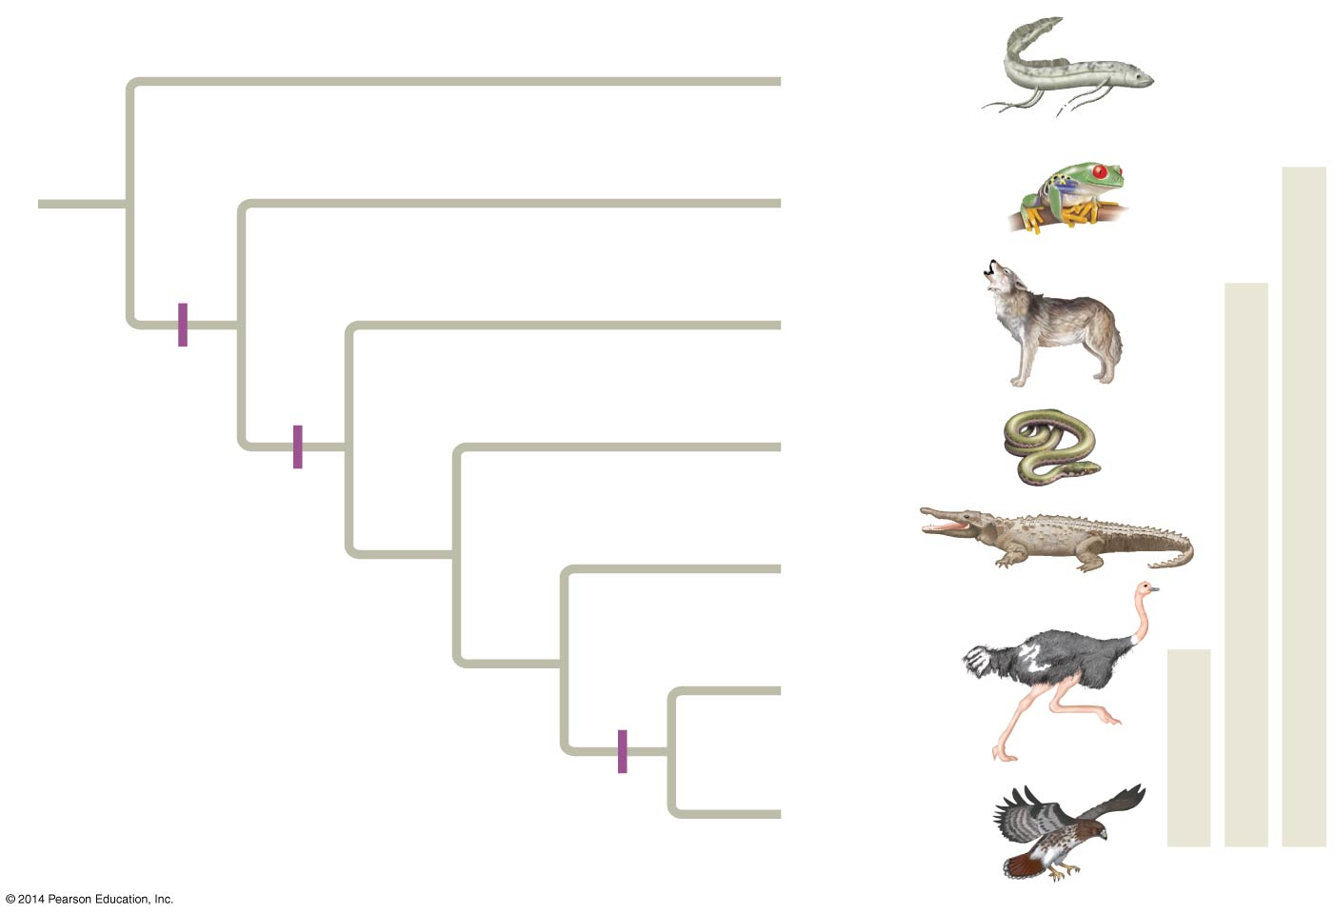Analogous structures
- What is homology?

- Label the trait associated with each hatch mark on the diagram

- What is biogeography and why is it important to the study of evolution?

- How do the fossil record and sedimentary rock provide evidence to evolution?

