Name _________________________
AP Biology
Chapter 21 - Genomes and Their Evolution

Guided Reading Assignment Campbell’s 10th Edition

Essential Knowledge
3.C.1 Biological systems have multiple processes that increase genetic variation
4.C.1 Variations in molecular units provides cells with a wider range of functions
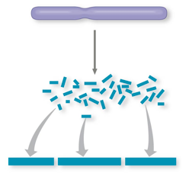LO 3.26 The student is able to explain the connection between genetic variation in organisms and phenotypic variation in populations.

- What was the goal of the human genome project?

- Label the 4 steps shown in the diagram of the whole-genome shotgun approach

- After the human genome was sequenced, how was that data analyzed and shared?

- What is a proteome?

- 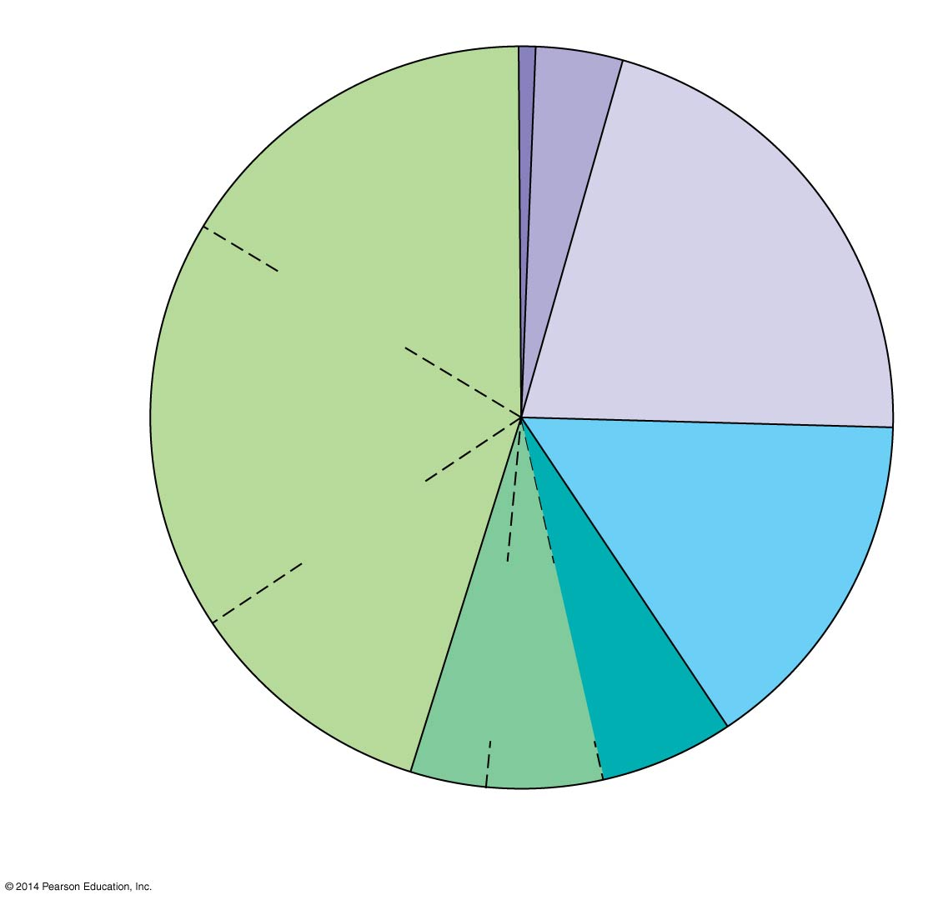Why might it be more practical to study proteomes than genomes?

- Label the diagram to show exons, regulatory sequences, noncoding DNA, and repetitive sequences.

- What percentage of the human genome is devoted to actively transcribed and translated genes?

- 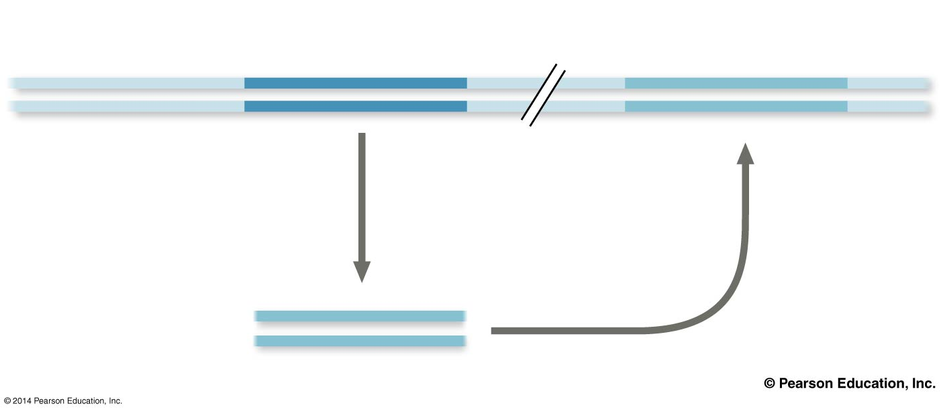What happens during transposition?

- Label the transposon, the copy and inserted gene in the diagram

- How do transposons contribute to genome evolution?

- How are short tandem repeats useful in biotechnology? (refer back to page 431)

- How does each of the following contribute to genome evolution?
  - Duplication

  - 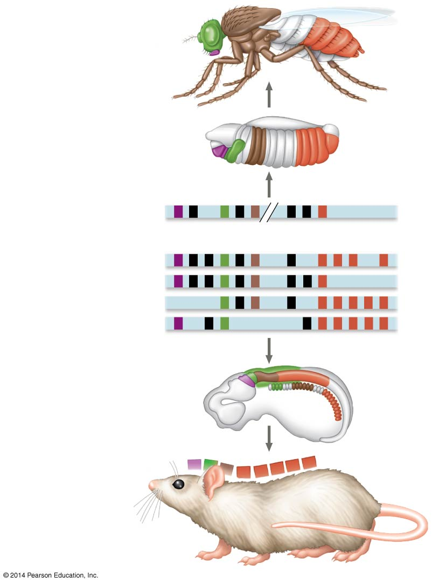Rearrangement

  - Mutation
- Describe how genome sequencing can be used to understand evolutionary relationships

- Some regions of the genomes are more similar than others. These similar regions are highly conserved. Why are some genes more likely to be conserved than others?

- What does the field of evo-devo study?

- What is the significance of a homeobox?

- Different animals have similar conserved genes repeated in different body segements. How does the regulation of these genes lead to different traits?

