**Name _________________________**

**AP Biology**

**Chapter 20 - DNA Tools and Biotechnology**

**Guided Reading Assignment Campbell’s 10th Edition**

**Essential Knowledge**

3.A.1 DNA, and in some cases RNA, is the primary source of heritable information

LO 3.5 The student can explain how heritable information can be manipulated using common technologies.

1. Describe 2 methods for sequencing DNA
2. Define the following
   1. DNA cloning
   2. plasmid
   3. Recombinant DNA
   4. Genetic engineering
   5. Biotechnology
   6. Gene cloning
3. Why did restriction enzymes evolve in bacteria?

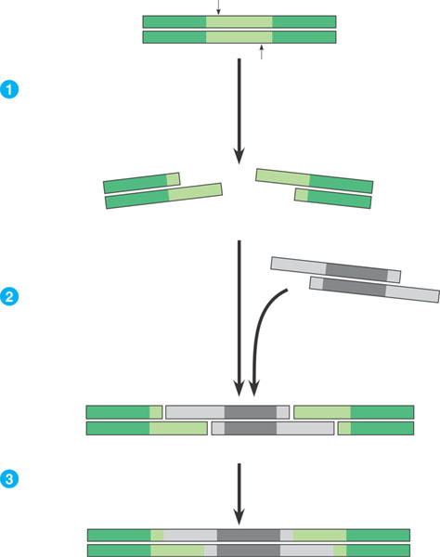

1. How are restriction enzymes used in DNA technology?
2. Define the following terms
   1. Restriction site
   2. Restriction fragments
   3. Sticky end
3. Label the following diagram.
4. Using the diagram – label the steps to cloning a human gene in a bacterial plasmid
5. Explain in your own words two ways that we know the cell clones carry the recombinant plasmids?
6. What is the purpose of nucleic acid hybridization? Why is the word hybrid used?

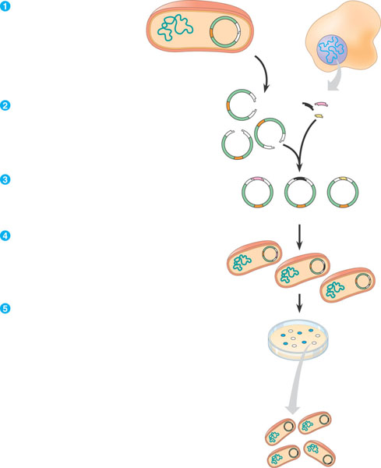

1. What is a complementary, short, single stranded nucleic acid that can be either DNA or RNA called?
2. Why do scientists use a radioactive isotope tag for the probes?

1. How is DNA denaturation different than protein denaturation?
2. Label the following steps of nucleic acid probe hybridization.

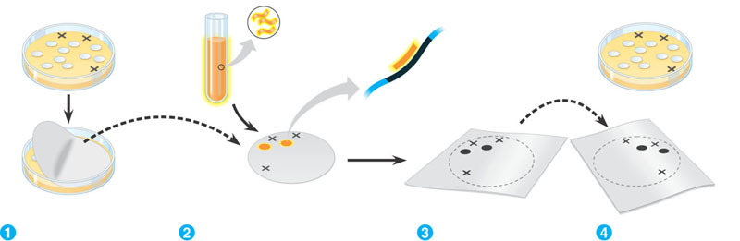

1. Define genomic library.

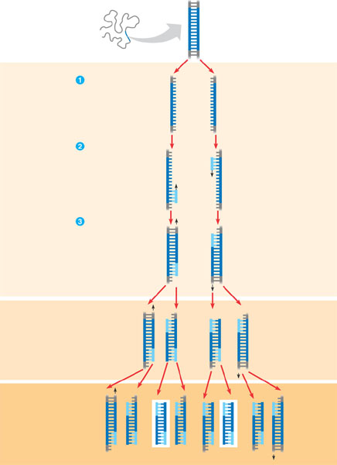

1. How are bacteriophages used for making genomic libraries and what are some of the advantages of this?

1. Why is PCR – polymerase chain reaction important in many aspects of biotechnology?
2. Label the diagram of PCR.
3. What is the purpose and general process of gel electrophoresis?

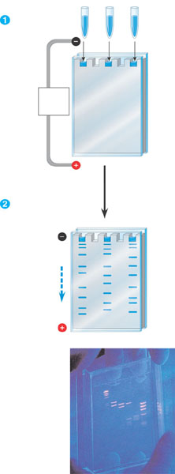

1. Label the diagram – focus on the **charge, molecule size and results.**

1. Define and explain the significance of RFLP’s – restriction length polymorphisms.
2. What was the purpose of the Human Genome Project?
3. Label the diagram outlining the Southern Blotting of DNA Fragments

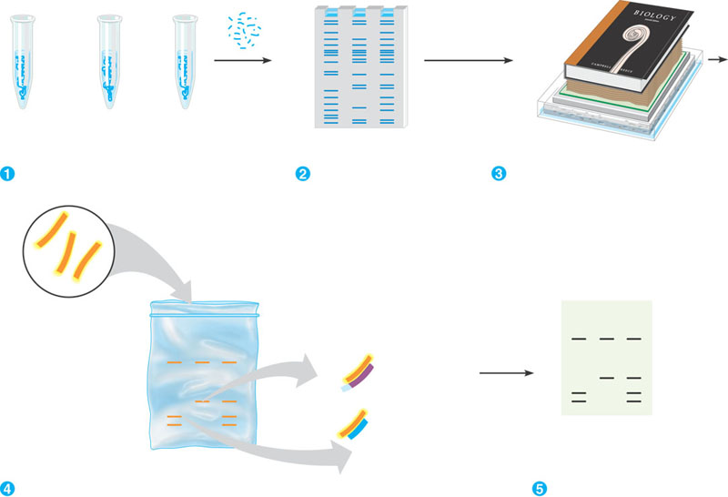

1. Why is genetic mapping considered a “relative mapping” as opposed to physical mapping?
2. What is the goal of DNA sequencing?
3. What is the basic concept of the whole-genome shotgun approach to sequencing?
4. Define genomics.
5. Is there a direct correlation between size of the genome and the complexity of the organism?
6. What is in vitro mutagenesis and what does it help the scientist understand?
7. What is proteomics?
8. Define single nucleotide polymorphisms.
9. What are some of the examples of the medical applications of biotechnology?
10. What are the basic steps in human gene therapy with a retroviral vector?

1. What is a DNA fingerprint?
2. What is a transgenic animal?
3. How are plasmids used in agriculture and genetic engineering in plants?
4. What are genetically modified foods and do you think that you have eaten any?