**Name _________________________**

**AP Biology**

**Chapter 2 - The Chemical Context of Life**

**Guided Reading Assignment Campbell’s 10th Edition**

**Essential Knowledge**

2.A.3 Organisms must exchange matter with the environment to grow, reproduce, and maintain organization

This chapter is a review of basic chemistry – we will be going through this chapter very quickly. If you have any problems – please see me before school for additional help.

1. Contrast the term element with compound.
2. Label the diagram below and define the terms that you label.

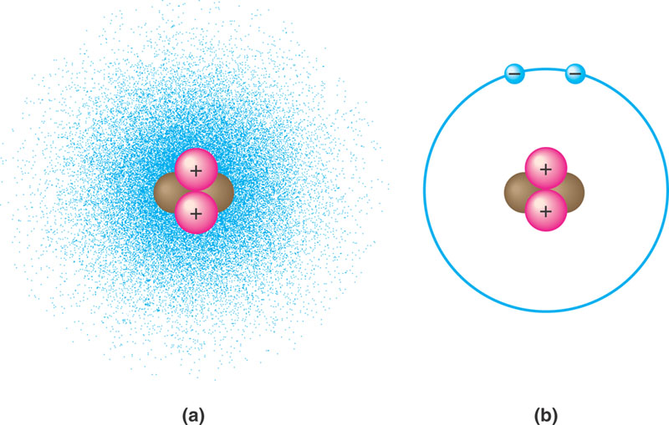

1. Contrast the terms atomic mass and atomic number.
2. What is the difference between the terms atomic mass and atomic weight?
3. What is an isotope and what is “special” about radioactive isotopes?
4. Explain how radioactive tracers are used in science?
5. Explain how the movement of electrons relates to the concept of potential energy – use the diagram to help answer the question.

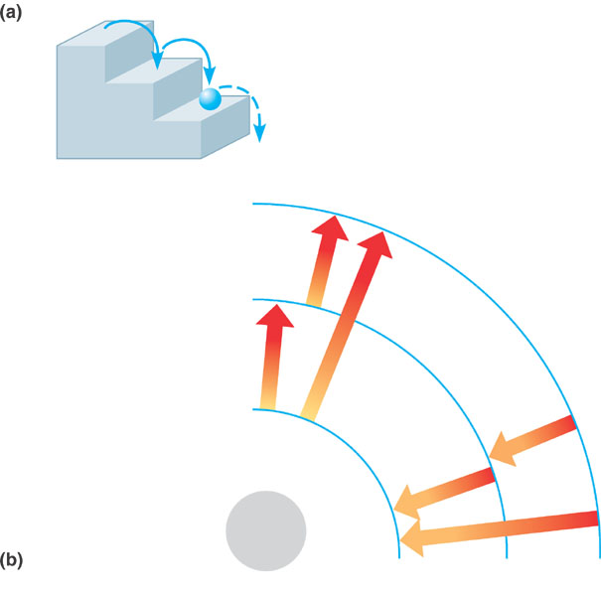

1. What determines interactions between atoms? Why are valence electrons important?
2. Define the following terms:
   1. Chemical bond
   2. Covalent bond
   3. Single bond
   4. Double bond
   5. Valence
   6. Electronegativity
   7. Nonpolar covalent bond
   8. Polar covalent bond
3. What is the difference between a structural and molecular formula?
4. How do ionic bonds compare with covalent bonds?
5. Compare and contrast hydrogen bonds and van der Waals interactions.
6. Based on the reading, what is an example, in a living system, of how molecular shape is critical?
7. Define a dynamic chemical equilibrium in terms of quantities of reactants and products. This is a critical concept!