Name _________________________
AP Biology
Chapter 19 - Regulation of Gene Regulation

Guided Reading Assignment Campbell’s 10th Edition

Essential Knowledge:
3.C.3 Viral replication results in genetic variation, and viral infection can introduce genetic variation into the hosts
3.A.1 DNA, and in some cases RNA, is the primary source of heritable information

LO 3.29 The student is able to construct an explanation of how viruses introduce genetic variation in host organisms.
LO 3.30 The student is able to use representations and appropriate models to describe how viral replication introduces genetic variation in the viral population.

- What are the two basic parts of a virus?

- What types of genomes may viruses contain?
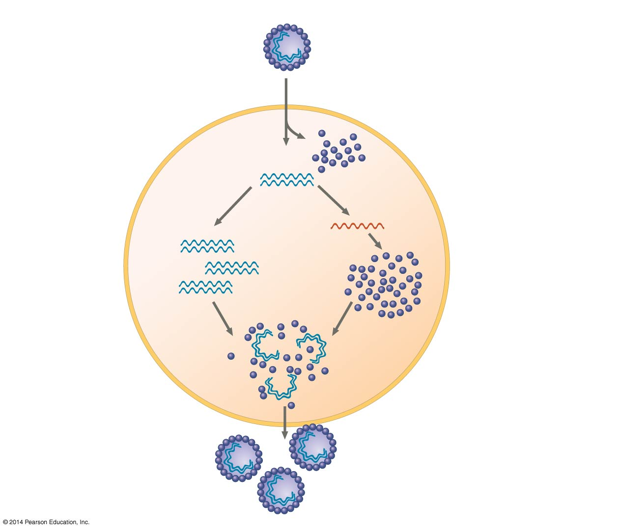
- Where do viruses reproduce?

- What shapes of capsid may viruses have?

- Label the 4 main stages of the virus reproductive cycle on the diagram provided

- How does the lytic virus life cycle differ from the lysogenic cycle?

- 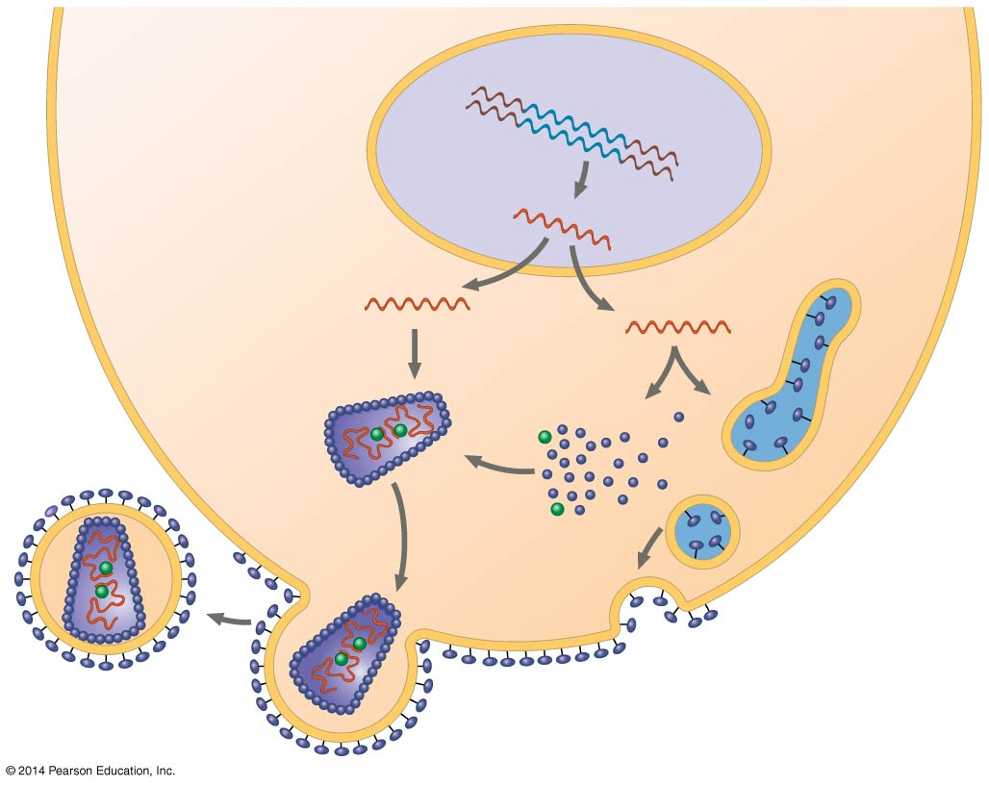 How do bacteria defend themselves against phages?

- What is the evolutionary significance of the mimivirus?

- HIV is a retrovirus. What is the role of reverse transcriptase in its life cycle?

- What is the evolutionary significance of introducing new genetic information into a host cell?

- On the diagram provided, use a star to show the stage where genetic information is introduced into the host cell?

- Is it believed that viruses evolved before or after the first cells appeared and what evidence is used to support the idea?
- What are vaccines?
- What are the three processes that contribute to the emergence of viral diseases?
- List and explain the two major routes that plant viruses are spread.
- What are viroids?

- Define prions.

