**Name _________________________**

**AP Biology**

**Chapter 18 - Regulation of Gene Regulation**

**Guided Reading Assignment Campbell’s 10th Edition**

**Essential Knowledge:**

3.B.1 Gene regulation results in differential gene expression, leading to cell specialization

3.B.2 A variety of intercellular and intracellular signal transmissions mediate gene expression

2.E.1 Timing and coordination of specific events are necessary for the normal development of an organism, and these events are regulated by a variety of mechanisms

4.A.3 Interactions between external stimuli and regulated gene expression result in specializations of cells, tissues and organs

LO 3.6 The student can predict how a change in a specific DNA or RNA sequence can result in changes in gene expression.

LO 3.18 The student is able to describe the connection between the regulation of gene expression and observed differences between different kinds of organisms.

LO 3.19 The student is able to describe the connection between the regulation of gene expression and observed differences between individuals in a population.

LO 3.20 The student is able to explain how the regulation of gene expression is essential for the processes and structures that support efficient cell function.

LO 3.21 The student can use representations to describe how gene regulation influences cell products and function.

LO 3.23 The student can use representations to describe mechanisms of the regulation of gene expression.

LO 4.7 The student is able to refine representations to illustrate how interactions between external stimuli and gene expression result in specialization of cells, tissues and organs.

LO 4.23 The student is able to construct explanations of the influence of environmental factors on the phenotype of an organism.

LO 4.24 The student is able to predict the effects of a change in an environmental factor on gene expression and the resulting phenotype of an organism.

LO 4.25 The student is able to use evidence to justify a claim that a variety of phenotypic responses to a single environmental factor can result from different genotypes within the population.

1. What type of organism regulates genes using an operon?
2. What is the key advantage of grouping genes of related function in to one transcription unit?
3. What are the 4 parts of the operon?

P

R

O

G

1. What does it mean to call the trp repressor protein ***allosteric***?
2. 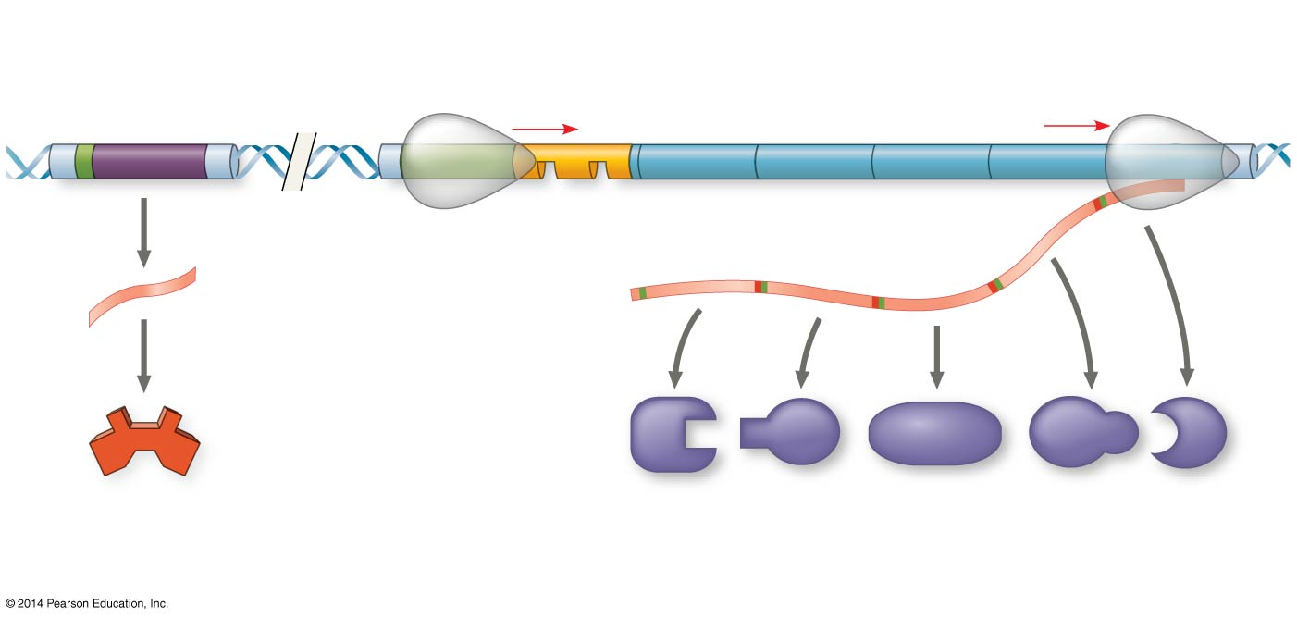The trp operon is repressible, what happens to the repressor when a cell has plenty of tryptophan?
3. Label PROG on the trp operon

1. What does the operator control?
2. What is the name for the operator, promoter, and the genes they control?
3. What can happen if the trp operon is turned “on”?
4. What turns the “switch” off?
5. How does a repressor work?
6. What gene controls the making of the trp repressor protein?

1. What are the two methods of negative gene regulation?

1. Why is the trp operon considered **repressible?**

1. 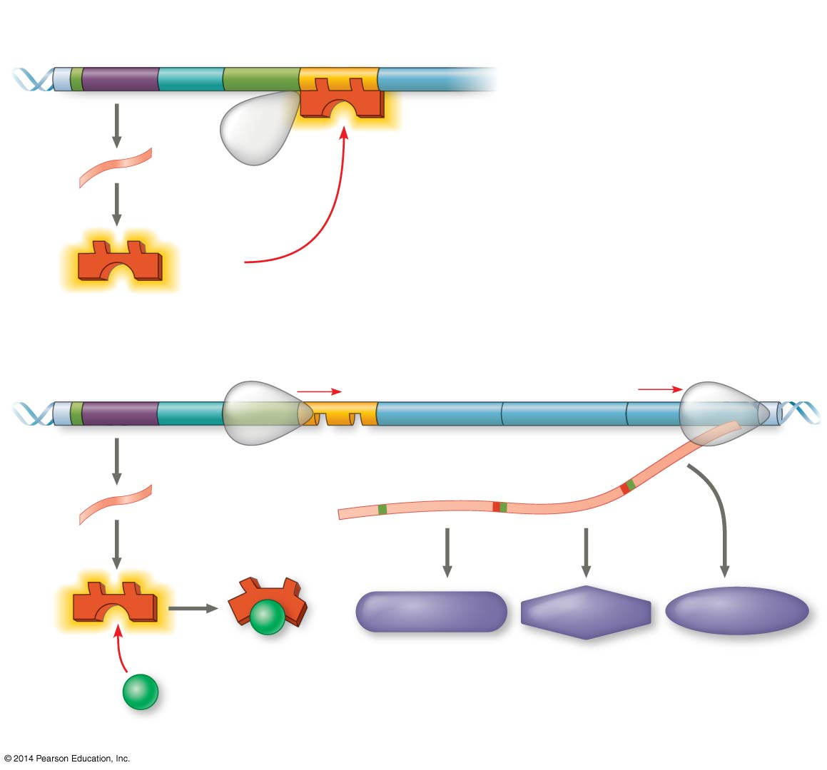 What is the definition of an **inducible** operon?
2. When is it most energy efficient to turn the lac operon off?
3. When is it most energy efficient to turn the lac operon on?
4. What does the inducer do?
5. How does a repressible operon differ from an inducible operon?
6. Why are repressible enzymes generally associated with anabolic pathways and how is this an advantage to the organism?
7. How does positive gene regulation work?
8. We stated in the beginning of the year that negative feedback has an on/off switch and positive feedback can only amplify the response – how does this statement connect with negative and positive gene regulation?
9. What is cell differentiation?
10. IF cells carry all of the genetic differences, why then are cells so unique – what is responsible for this?
11. 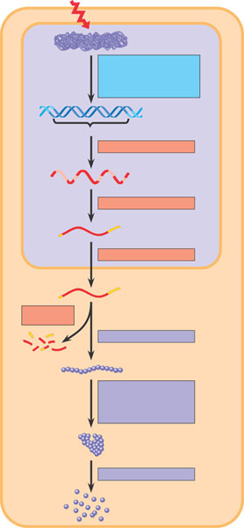In the diagram below – put a star next to all of the potential locations for gene expression regulation in eukaryotic cells. How does this compare with prokaryotic cells?
12. What effect do the following have on gene expression?
    1. Histone acetylation
    2. Histone deacteylation

* 1. DNA methylation

1. How does methylation relate to genomic imprinting?
2. Define epigenetic inheritance.
3. How do the following control elements assist in regulation?
   1. Transcription factors
   2. Enhancers
   3. Activators
   4. Repressors

Use the diagram below to explain the interactions of enhancers and transcription activators.

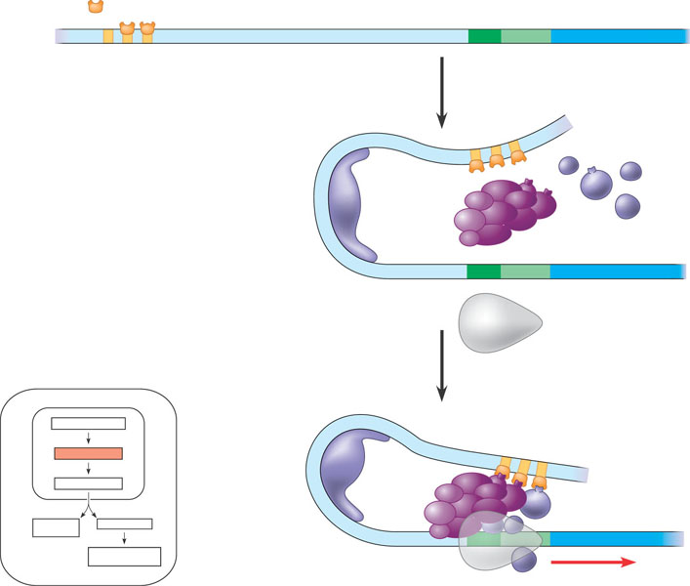

1. Explain how RNA processing is a mechanism of post-transcriptional regulation.
2. What role do microRNA’s play in post-transcriptional regulation? Use the diagram below to help you explain.  
   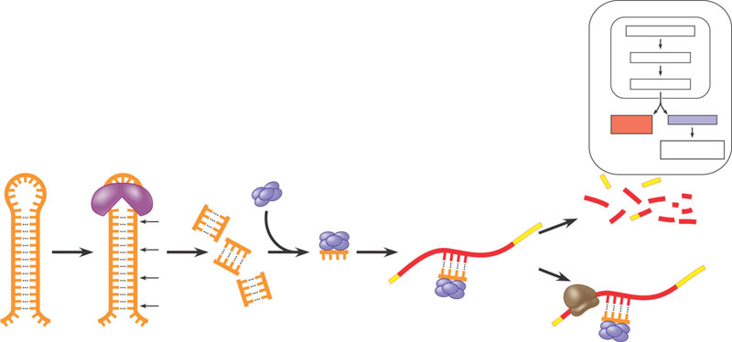
3. What is RNA interference?
4. How does translation provide another opportunity for control?
5. What is a proteasomes?
6. What is the difference between oncogenes,proto-oncogenes and tumor-suppressor genes?
7. What is the ras gene?
8. 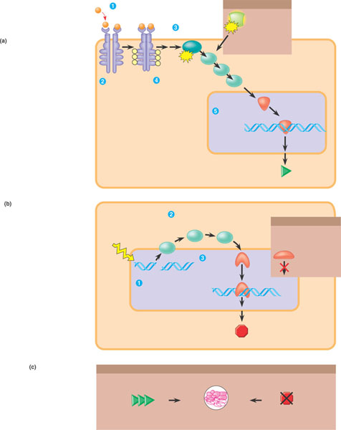What is the p53 gene?
9. Label the diagram below that describes the signaling pathways that regulate cell division.
10. Why is said that people inherit predispositions to cancer not cancer itself?
11. What are the types of DNA sequences in the human genome and what % of the genome are they?
12. What is the difference between transposons and retrotransposons.   
    Use the diagram below to help you answer the question.  
    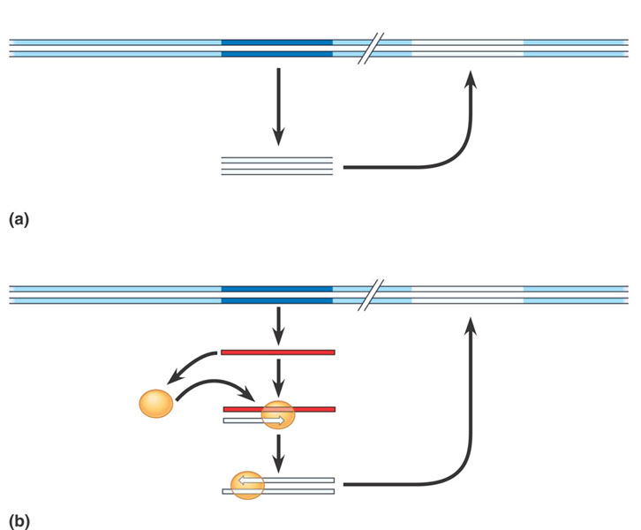
13. What are Alu elements?
14. What are multi-gene families?
15. What are pseudogenes?
16. How can errors during meiosis lead to duplication of genes?
17. What are three ways transposable elements are thought to have contributes to the evolution of the genome?