Name _________________________
AP Biology
Chapter 1 – Evolution, the Themes of Biology and Scientific Inquiry

Guided Reading Assignment Campbell’s 10th Edition

Essential Knowledge
None

- List 6 properties of life

- Label each of the 10 levels of organization shown on the diagram below

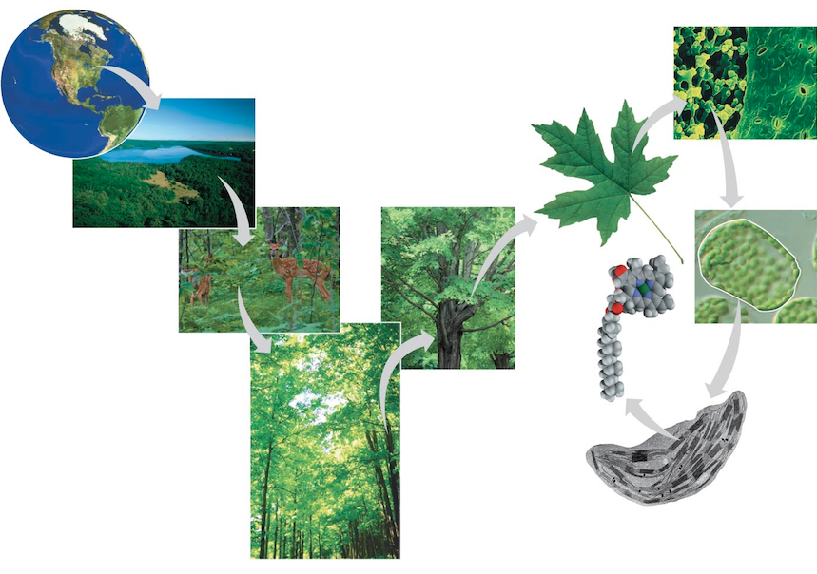

- Define emergent property and give a specific example

- Label the three domains of life on the diagram below

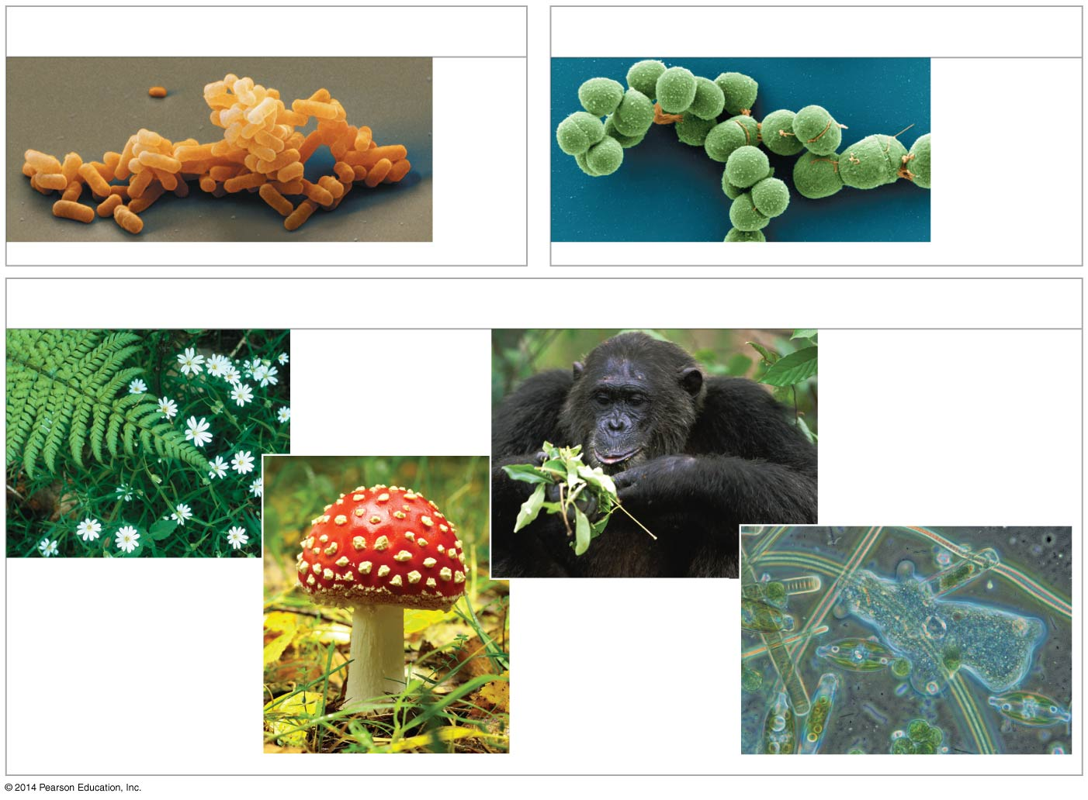
- Give two examples of types of feedback regulation.

- Complete the following diagram using one word in each box.
